CinePlus

An Online Movie Booking Dashboard

**PROJECT REPORT**

COMPUTER SCIENCE

Name- Shiva Shaklya

Board Roll no.- 21663386

School- DPS Indirapuram

Session- 2021-22

**Certificate**

This is to certify that SHIVA SHAKLYA of Class XII-F has prepared a project on “CINEPLUS: MOVIE BOOKING PROGRAM”. The project is a result of her efforts and endeavors. This project is found worthy of acceptance as the final project report for the subject Computer Science of Class XII.

She has prepared this project under my guidance.

Ms. Rinkoo Gupta

(Computer Science)

(DPS Indirapuram)

**Acknowledgement**

I would like to express a deep sense of gratitude towards my computer science teacher Ms. Rinkoo Gupta Ma’am for guiding through the course of my project. She always evinced keen interest in my work and her constructive advice and constant motivation have been responsible for the successful completion of the project.

I would like to extend my sincere thanks to everyone who have helped directly or indirectly in the completion of the project.

**Index**

Table of Contents

INTRODUCTION 5

MySQL and CSV files 7

CODE 10

OUTPUT 62

CONCLUSION 80

FUTURE IMPROVEMENTS 81

BIBLIOGRAPHY 82

# INTRODUCTION

The aim of the project was to build an online movie booking dashboard called “CINEPLUS”.

**Working Description**

The build-up of the user-menu section is as follows:

1. Viewer

1.1. Register

1.2. Sign In

Δ Choose a Genre

• Click on a Movie

•• Book Now

••• Name, Date of Birth and Seats Required

•••• Confirm Booking + Exit

1.3. Back

2. Manager

2.1. Sign In

Δ Booking Details

Δ Update Poster

• Choose a Genre

•• Click on a Movie

•••Enter New Movie + Click Enter + Ok

Δ Database Change

∞ View Movie

∞ Change Details

• Seats Available

•• Movie Name + No. Of Seats + Click Enter

• Change Show Timings

•• New Show Timings + Click Enter

• Cost Per Head

•• Enter Cost + Click Enter

• Add Movies

•• Enter Movie Details Required + Click Enter

• Delete Movies

•• Movie Name + Click Enter

2.2. Change Password

Δ Current Password + New Password

2.3. Back

# MySQL and CSV files

Within MySQL 5 tables have been used:

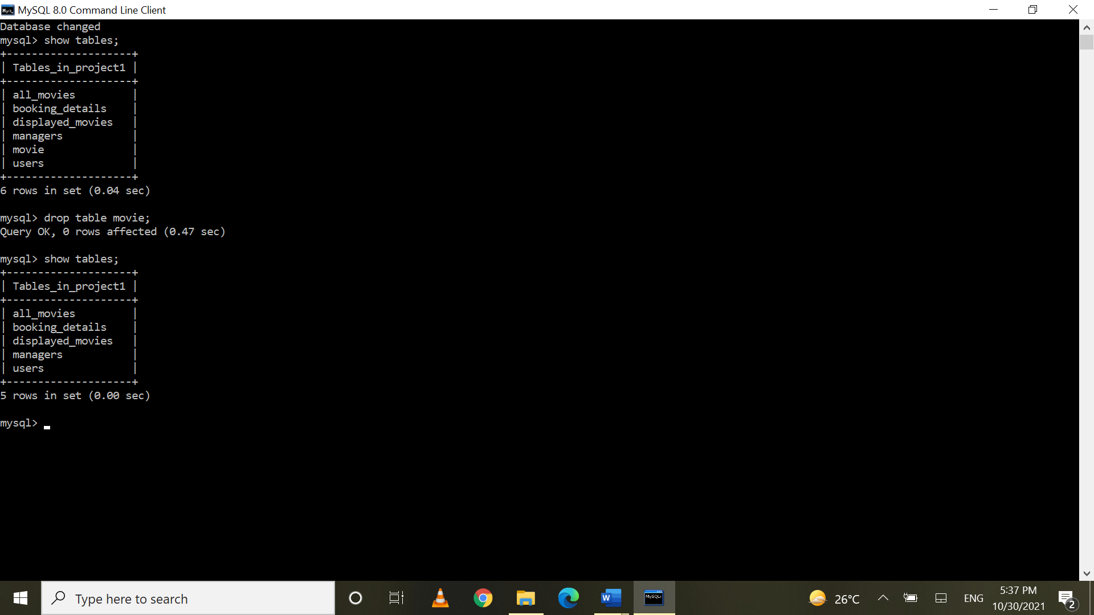

1. 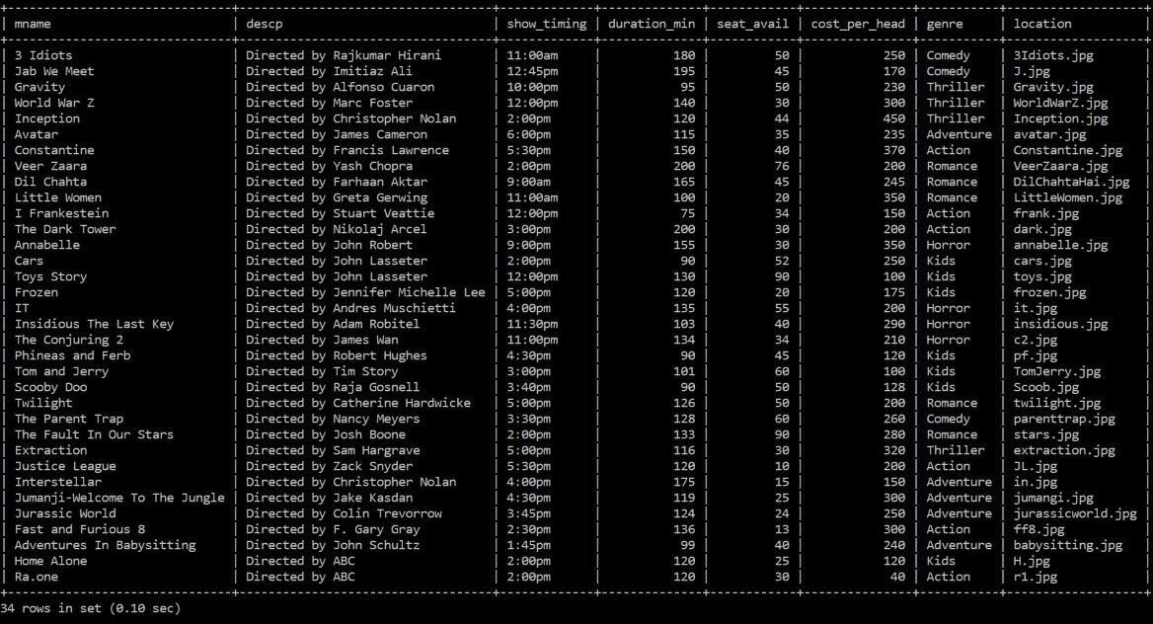All_movies
2. 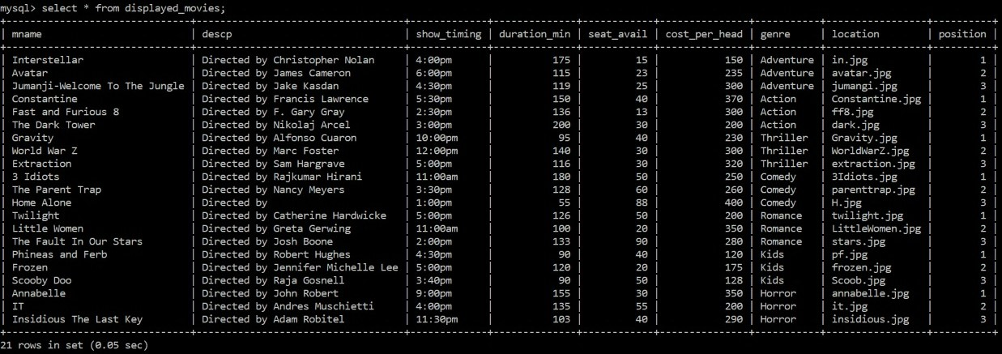Displayed_movies
3. Booking_details

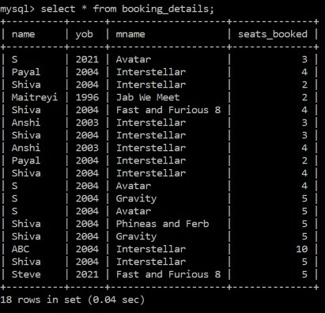

1. 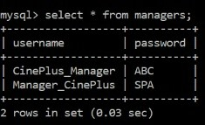Managers
2. 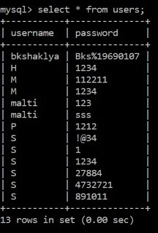Users

CSV Files

Similar data has been stored in the csv files to allow for the setup of the program in different computers.

# CODE

To ensure clarity and proper organization, 3 separate modules have been created for the program:

1. GUI_Interface
2. ViewerModule
3. ManagerModule

**1. GUI_Interface**

Code:

from tkinter import *

from tkinter import ttk

from tkinter import messagebox

import ViewerModule

import mysql.connector as con

mycon=con.connect(host="localhost",username="root",passwd="Shiva09@04",database="project1")

cur=mycon.cursor()

from PIL import Image,ImageTk

from tkinter.font import Font

import ManagerModule

#Sign In window

window1=Tk()

window1.title("Window 1")

window1.geometry("1300x800")

load=Image.open(r"C:\Users\MALTI SHAKLYA\Desktop\Shiva\Python\Project\Bg.jpg")

render=ImageTk.PhotoImage(load)

img=Label(window1,image=render)

img.place(x=0,y=0)

'''width=window1.winfo_screenwidth()

height=window1.winfo_screenheight()

l=Label(window1,text=f"width:{width} height:{height}")

l.pack()'''

def click_B1():

global pop1

global tname

global tpassword

pop1=Toplevel(window1)

pop1.title("Viewer Sign In")

pop1["bg"]="White"

lname=Label(pop1,text="Enter Username",font=("Copperplate gothic",10),fg="black",bg="white")

lname.place(x=50,y=25)

tname=Entry(pop1,width=25)

tname.place(x=200,y=25)

lpassword=Label(pop1, text="Enter Password",font=("Copperplate gothic",10),fg="black",bg="white")

lpassword.place(x=50,y=55)

tpassword=Entry(pop1,width=25,show="*")

tpassword.place(x=200,y=55)

register=Button(pop1,text="Register",font=("Copperplate gothic",10),fg="black",bg="Orange",cursor="hand2",command=click_register)

register.place(x=100,y=90)

sign=Button(pop1,text="Sign In",font=("Copperplate gothic",10),fg="black",bg="light green",cursor="hand2",command=lambda:click_sign(B1))

sign.place(x=175,y=90)

back=Button(pop1,text="Back",font=("Copperplate gothic",10),fg="black",bg="red",cursor="hand2",command=click_back)

back.place(x=245,y=90)

pop1.geometry("550x200")

pop1.mainloop()

def click_B2():

global pop1

global tname

global tpassword

pop1=Toplevel(window1)

pop1.title("Manager Sign In")

pop1["bg"]="White"

lname=Label(pop1,text="Enter Username",font=("Copperplate gothic",10),fg="black",bg="white")

lname.place(x=50,y=25)

tname=Entry(pop1,width=25)

tname.place(x=200,y=25)

lpassword=Label(pop1, text="Enter Password",font=("Copperplate gothic",10),fg="black",bg="white")

lpassword.place(x=50,y=55)

tpassword=Entry(pop1,width=25,show="*")

tpassword.place(x=200,y=55)

sign=Button(pop1,text="Sign In",font=("Copperplate gothic",10),fg="black",bg="light green",cursor="hand2",command=lambda:click_sign(B2))

sign.place(x=100,y=90)

change=Button(pop1,text="Change Password",font=("Copperplate gothic",10),fg="black",bg="Orange",cursor="hand2",command=lambda:change_password(tname.get()))

change.place(x=168,y=90)

back=Button(pop1,text="Back",font=("Copperplate gothic",10),fg="black",bg="red",cursor="hand2",command=click_back)

back.place(x=300,y=90)

pop1.geometry("550x200")

pop1.mainloop()

def click_register():

global l1alert

username=tname.get()

password=tpassword.get()

if len(username)>0 and len(password)>0:

cur.execute("use project1;")

query2=("select username from users;")

cur.execute(query2)

data=cur.fetchall()

try:

if username not in data:

query2=("insert into users (username,password) values(%s,%s);")

data=(username,password)

cur.execute(query2,data)

mycon.commit()

pop1.destroy()

ViewerModule.open_window2()

except:

l1alert.destroy()

l1alert=Label(pop1,text="username already exists, kindly try another username",font=("Copperplate gothic",10),bg="#3399FF",fg="white")

l1alert.place(x=80,y=145)

else:

l1alert=Label(pop1,text="Check if data has been inserted correctly and try again",font=("Copperplate gothic",10),bg="dark red",fg="white")

l1alert.place(x=80,y=145)

def click_sign(b):

username=tname.get()

password=tpassword.get()

global l1alert

if b==B1:

if len(username)>0 and len(password)>0:

cur.execute("use project1;")

query2=("select username,password from users;")

cur.execute(query2)

data=cur.fetchall()

if (username,password) in data:

pop1.destroy()

ViewerModule.open_window2()

else:

l1alert.destroy()

l1alert=Label(pop1,text="Incorrect username or password",font=("Copperplate gothic",10),bg="orange",fg="white")

l1alert.place(x=80,y=145)

else:

l1alert=Label(pop1,text="Check if data has been inserted correctly and try again",font=("Copperplate gothic",10),bg="dark red",fg="white")

l1alert.place(x=80,y=145)

if b==B2:

if len(username)>0 and len(password)>0:

query2=("select username,password from managers;")

cur.execute(query2)

data=cur.fetchall()

if (username,password) in data:

pop1.destroy()

ManagerModule.open_window3()

else:

l2alert=Label(pop1,text="Incorrect username or password",font=("Copperplate gothic",10),bg="orange",fg="white")

l2alert.place(x=80,y=145)

else:

lalert=Label(pop1,text="Check if data has been inserted correctly and try again",font=("Copperplate gothic",10),bg="dark red",fg="white")

lalert.place(x=80,y=145)

def click_back():

pop1.destroy()

def new_password(user,recent,new):

print(user)

query="select password from managers where username='{}'".format(user)

cur.execute(query)

data=cur.fetchall()

for i in data:

if list(i)==[recent]:

query="update managers set password='{}' where username='{}'".format(new,user)

cur.execute(query)

mycon.commit()

messagebox.showinfo(title="Change Password",message="Password changed Successfully")

change.destroy()

print("Password updated")

else:

change.destroy()

messagebox.showerror(title="Change Password", message="Password Incorrect")

print("Incorrect Password")

def change_password(username):

global change

pop1.destroy()

change=Toplevel(window1)

change.title("Change Password")

change["bg"]="White"

change.geometry("550x200")

userL=Label(change,text="Enter current username: ",font=("Copperplate gothic",10),fg="black",bg="white")

userL.place(x=50,y=25)

userT=ttk.Entry(change,width=25)

userT.place(x=200,y=25)

recentL=Label(change,text="Enter current password: ",font=("Copperplate gothic",10),fg="black",bg="white")

recentL.place(x=50,y=50)

recentT=ttk.Entry(change,width=25)

recentT.place(x=200,y=50)

newL=Label(change,text="Enter new password: ",font=("Copperplate gothic",10),fg="black",bg="white")

newL.place(x=60,y=75)

newT=ttk.Entry(change,width=25)

newT.place(x=210,y=75)

C=Button(change,text="Enter",font=("Copperplate gothic",10),fg="black", bg="blue",command=lambda:new_password(userT.get(),recentT.get(),newT.get()))

C.place(x=150,y=100)

def csv_write():

import csv

#Movie

f=open("Movie_Details.csv","w",newline="")

w=csv.writer(f)

q=("select * from movie")

cur.execute(q)

d=cur.fetchall()

w.writerows(d)

#users

f=open("User_Details.csv","w",newline="")

w=csv.writer(f)

q=("select * from users")

cur.execute(q)

d=cur.fetchall()

w.writerows(d)

#Managers

f=open("Manager_Details.csv","w",newline="")

w=csv.writer(f)

q=("select * from managers")

cur.execute(q)

d=cur.fetchall()

w.writerows(d)

print("data inserted")

#Displayed movies

import csv

f=open("Displayed_movies.csv","w",newline="")

w=csv.writer(f)

q=("select * from movies")

cur.execute(q)

d=cur.fetchall()

w.writerows(d)

print("data inserted")

#Sign In Text

f=Font(family="Craftsman PERSONAL USE",size="62")

img=PhotoImage(file=r"C:\Users\MALTI SHAKLYA\Desktop\Shiva\Python\Project\T.png")

L=Label(window1,image=img,bg="black")

L.place(x=400,y=60)

'''L2=Label(window1,text="OR",font=("Copperplate gothic",20,"bold"),fg="white",bg="black")

L2.place(x=550,y=230)'''

#Viewer Sign In

img1=PhotoImage(file=r"C:\Users\MALTI SHAKLYA\Desktop\Shiva\Python\Project\viewer.png")

B1=Button(window1,image=img1, bd=0,bg="black",activebackground="#000000",cursor="hand2",command=click_B1)

B1.place(x=400,y=237)

#Manager Sign In

img2=PhotoImage(file=r"C:\Users\MALTI SHAKLYA\Desktop\Shiva\Python\Project\manager.png")

B2=Button(window1,image=img2,bd=0,bg="#000000",activebackground="#000000",cursor="hand2",command=click_B2)

B2.place(x=660,y=237)

#csvfile_write()

window1.mainloop()

**2. ViewerModule**

Code:

from tkinter import *

from PIL import Image,ImageTk

from tkinter.font import Font

from tkinter import ttk

from tkinter import messagebox

import mysql.connector as con

mycon=con.connect(host="localhost",username="root",passwd="Shiva09@04",database="project1")

cur=mycon.cursor()

def click_book(N):

global book

pop2.destroy()

book=Toplevel(window2)

book.title("Enter Details")

book['bg']="#00CCCC"

book.geometry("500x400")

nameL=Label(book,text="Enter Name",font=("Copperplate gothic",10),bg="#00CCCC",fg="black")

nameL.place(x=100,y=20)

name=ttk.Entry(book,width=20)

name.place(x=180,y=20)

dobL=Label(book,text="Select Year of Birth",font=("Copperplate gothic",10),bg="#00CCCC",fg="black")

dobL.place(x=100,y=80)

#creating birth year list

year=[]

for i in range(2021,1920,-1):

year+=[i]

#

y=IntVar()

dob=ttk.Combobox(book,textvariable=y)

dob['values']=year

dob.place(x=240,y=80)

dob.current(0)

seatsL=Label(book,text="No. of Seats to be Booked",font=("Copperplate gothic",10),bg="#00CCCC",fg="black")

seatsL.place(x=100,y=140)

seats=ttk.Entry(book,width=5)

seats.place(x=260,y=140)

query="select seat_avail from displayed_movies where mname='{}';".format(N)

cur.execute(query)

avail=cur.fetchall()

for i in avail:

a=int(i[0])

seat_avail=Label(book,text="Seats availaible: {}".format(a),font=("Copperplate gothic",10),bg="#00CCCC",fg="black")

seat_avail.place(x=290,y=140)

confirm=Button(book,text="Confirm Booking",font=("Copperplate gothic",10),bg="dark blue",fg="white",command=lambda:BookingDetails_toSQL(name,seats,y,N))

confirm.place(x=170,y=200)

book.mainloop()

def BookingDetails_toSQL(name,seats,y,N):

#ADD DATE TIME STAMP

try:

query="create table booking_details (name varchar(25),yob int,mname varchar(40),seats_booked int);"

cur.execute(query)

query="insert into booking_details VALUES('{}',{},'{}',{})".format(name.get(),y.get(),N,seats.get())

cur.execute(query)

except:

query="insert into booking_details VALUES('{}',{},'{}',{})".format(name.get(),y.get(),N,seats.get())

cur.execute(query)

#

query="select seat_avail from displayed_movies where mname='{}';".format(N)

cur.execute(query)

avail=cur.fetchall()

for i in avail:

a=int(i[0])

new_seats=a-int(seats.get())

query1="update displayed_movies set seat_avail={} where mname='{}';".format(new_seats,N)

cur.execute(query1)

query2="update all_movies set seat_avail={} where mname='{}';".format(new_seats,N)

cur.execute(query2)

mycon.commit()

#CREATE INVOICE

book.destroy()

messagebox.showinfo(message="BOOKING CONFIRMED",parent=window2)

def details(N):

global s

g="\n"

query="select descp,cost_per_head,seat_avail,show_timing,duration_min,genre from displayed_movies where mname='{}';".format(N)

cur.execute(query)

data=cur.fetchall()

print(data)

for i in data:

i=list(i)

s="Description: {}".format(i[0])+g+"Cost per seat: {}".format(i[1])+g+"Seats Availaible: {}".format(i[2])+g+"Show Timings: {}".format(i[3])+g+"Duration: {}".format(i[4])+"min"+g+"genre: {}".format(i[5])

print(s)

descp=Label(pop2,text=s,font=("Copperplate gothic",15),bg="black",fg="white")

descp.place(x=100,y=50)

def open_pop2(N):

global pop2

pop2=Toplevel(window2)

pop2.title("Book Movie")

pop2['bg']="black"

pop2.geometry("550x400")

#Movie Title

descp=Label(pop2,text=N,font=("Algerian Regular",20),bg="black",fg="white")

descp.place(x=200,y=0)

details(N)

#Book Button

img=ImageTk.PhotoImage(Image.open("book.png"))

book=Button(pop2,image=img,bg="black",activebackground="black",border=0,cursor="hand2",command=lambda:click_book(N))

book.place(x=200,y=250)

pop2.mainloop()

def destroy_window2():

window2.destroy()

open_window2()

def open_window2():

global GB

global GL

global window2

global genre

window2=Toplevel()

window2.title("Movie Booking Dashboard")

window2.geometry("1300x800")

load=Image.open(r"C:\Users\MALTI SHAKLYA\Desktop\Shiva\Python\Project\H12.jpg")

r=ImageTk.PhotoImage(load)

img=Label(window2,image=r)

img.place(x=0,y=0)

#genre Combobox

n=StringVar()

genre=ttk.Combobox(window2,textvariable=n)

genre['values']=["Action","Adventure","Thriller","Comedy","Romance","Horror","Kids special"]

genre.place(x=300,y=200)

genre.current(0)

GL=Label(window2,text="Choose a Genre")

GL.place(x=200,y=200)

GB=Button(window2,text="GO",cursor="hand2",command=lambda:choice(n))

GB.place(x=500,y=200)

window2.mainloop()

def choice(n):

global img1,img2,img3

if n.get()=="Adventure":

GB.destroy()

GL.destroy()

genre.destroy()

load1=Image.open("ADVENTURE.jpg")

r1=ImageTk.PhotoImage(load1)

img12=Label(window2,image=r1)

img12.place(x=0,y=0)

imageB=PhotoImage(file="button.png")

B=Button(window2,image=imageB, bd=0 ,cursor="hand2",command=destroy_window2)

B.place(x=580,y=540)

#poster1

query1="select * from displayed_movies where genre='Adventure' and position=1;"

cur.execute(query1)

data=list(cur.fetchall())

n1=data[0][0]

location=data[0][-2]

img1=ImageTk.PhotoImage(Image.open(location))

p1=Button(window2,image=img1,cursor="hand2",command=lambda:open_pop2(n1))

p1.place(x=290,y=180)

mycon.commit()

#poster2

query1="select * from displayed_movies where genre='Adventure' and position=2;"

cur.execute(query1)

data=list(cur.fetchall())

n2=data[0][0]

location=data[0][-2]

img2=ImageTk.PhotoImage(Image.open(location))

p2=Button(window2,image=img2,cursor="hand2",command=lambda:open_pop2(n2))

p2.place(x=540,y=180)

mycon.commit()

#poster3

query1="select * from displayed_movies where genre='Adventure' and position=3;"

cur.execute(query1)

data=list(cur.fetchall())

n3=data[0][0]

location=data[0][-2]

img3=ImageTk.PhotoImage(Image.open(location))

p3=Button(window2,image=img3,cursor="hand2",command=lambda:open_pop2(n3))

p3.place(x=790,y=180)

mycon.commit()

elif n.get()=="Action":

loadAC=Image.open("ACTION.jpg")

rAC=ImageTk.PhotoImage(loadAC)

img12AC=Label(window2,image=rAC)

img12AC.place(x=0,y=0)

imageB=PhotoImage(file="button.png")

B=Button(window2,image=imageB, bd=0 ,cursor="hand2",command=destroy_window2)

B.place(x=580,y=540)

#poster1

query1="select * from displayed_movies where genre='Action' and position=1;"

cur.execute(query1)

data=list(cur.fetchall())

n1=data[0][0]

location=data[0][-2]

img1=ImageTk.PhotoImage(Image.open(location))

p1=Button(window2,image=img1,cursor="hand2",command=lambda:open_pop2(n1))

p1.place(x=290,y=180)

mycon.commit()

#poster2

query1="select * from displayed_movies where genre='Action' and position=2;"

cur.execute(query1)

data=list(cur.fetchall())

n2=data[0][0]

location=data[0][-2]

img2=ImageTk.PhotoImage(Image.open(location))

p2=Button(window2,image=img2,cursor="hand2",command=lambda:open_pop2(n2))

p2.place(x=540,y=180)

mycon.commit()

#poster3

query1="select * from displayed_movies where genre='Action' and position=3;"

cur.execute(query1)

data=list(cur.fetchall())

n3=data[0][0]

location=data[0][-2]

img3=ImageTk.PhotoImage(Image.open(location))

p3=Button(window2,image=img3,cursor="hand2",command=lambda:open_pop2(n3))

p3.place(x=790,y=180)

mycon.commit()

elif n.get()=="Thriller":

loadT=Image.open("THRILLER.jpg")

rT=ImageTk.PhotoImage(loadT)

imgT=Label(window2,image=rT)

imgT.place(x=0,y=0)

imageB=PhotoImage(file="button.png")

B=Button(window2,image=imageB, bd=0 ,cursor="hand2",command=destroy_window2)

B.place(x=580,y=540)

#poster1

query1="select * from displayed_movies where genre='Thriller' and position=1;"

cur.execute(query1)

data=list(cur.fetchall())

n1=data[0][0]

location=data[0][-2]

img1=ImageTk.PhotoImage(Image.open(location))

p1=Button(window2,image=img1,cursor="hand2",command=lambda:open_pop2(n1))

p1.place(x=290,y=180)

mycon.commit()

#poster2

query1="select * from displayed_movies where genre='Thriller' and position=2;"

cur.execute(query1)

data=list(cur.fetchall())

n2=data[0][0]

location=data[0][-2]

img2=ImageTk.PhotoImage(Image.open(location))

p2=Button(window2,image=img2,cursor="hand2",command=lambda:open_pop2(n2))

p2.place(x=540,y=180)

mycon.commit()

#poster3

query1="select * from displayed_movies where genre='Thriller' and position=3;"

cur.execute(query1)

data=list(cur.fetchall())

n3=data[0][0]

location=data[0][-2]

img3=ImageTk.PhotoImage(Image.open(location))

p3=Button(window2,image=img3,cursor="hand2",command=lambda:open_pop2(n3))

p3.place(x=790,y=180)

mycon.commit()

elif n.get()=="Comedy":

loada=Image.open("COMEDY.jpg")

ra=ImageTk.PhotoImage(loada)

img125=Label(window2,image=ra)

img125.place(x=0,y=0)

imageB=PhotoImage(file="button.png")

B=Button(window2,image=imageB, bd=0 ,cursor="hand2",command=destroy_window2)

B.place(x=580,y=540)

#poster1

query1="select * from displayed_movies where genre='Comedy' and position=1;"

cur.execute(query1)

data=list(cur.fetchall())

n1=data[0][0]

location=data[0][-2]

img1=ImageTk.PhotoImage(Image.open(location))

p1=Button(window2,image=img1,cursor="hand2",command=lambda:open_pop2(n1))

p1.place(x=290,y=180)

mycon.commit()

#poster2

query1="select * from displayed_movies where genre='Comedy' and position=2;"

cur.execute(query1)

data=list(cur.fetchall())

n2=data[0][0]

location=data[0][-2]

img2=ImageTk.PhotoImage(Image.open(location))

p2=Button(window2,image=img2,cursor="hand2",command=lambda:open_pop2(n2))

p2.place(x=540,y=180)

mycon.commit()

#poster3

query1="select * from displayed_movies where genre='Comedy' and position=3;"

cur.execute(query1)

data=list(cur.fetchall())

n3=data[0][0]

location=data[0][-2]

img3=ImageTk.PhotoImage(Image.open(location))

p3=Button(window2,image=img3,cursor="hand2",command=lambda:open_pop2(n3))

p3.place(x=790,y=180)

mycon.commit()

elif n.get()=="Romance":

loadR=Image.open("ROMANCE.jpg")

rR=ImageTk.PhotoImage(loadR)

img126=Label(window2,image=rR)

img126.place(x=0,y=0)

imageB=PhotoImage(file="button.png")

B=Button(window2,image=imageB, bd=0 ,cursor="hand2",command=destroy_window2)

B.place(x=580,y=540)

#poster1

query1="select * from displayed_movies where genre='Romance' and position=1;"

cur.execute(query1)

data=list(cur.fetchall())

n1=data[0][0]

location=data[0][-2]

img1=ImageTk.PhotoImage(Image.open(location))

p1=Button(window2,image=img1,cursor="hand2",command=lambda:open_pop2(n1))

p1.place(x=290,y=180)

mycon.commit()

#poster2

query1="select * from displayed_movies where genre='Romance' and position=2;"

cur.execute(query1)

data=list(cur.fetchall())

n2=data[0][0]

location=data[0][-2]

img2=ImageTk.PhotoImage(Image.open(location))

p2=Button(window2,image=img2,cursor="hand2",command=lambda:open_pop2(n2))

p2.place(x=540,y=180)

mycon.commit()

#poster3

query1="select * from displayed_movies where genre='Romance' and position=3;"

cur.execute(query1)

data=list(cur.fetchall())

n3=data[0][0]

location=data[0][-2]

img3=ImageTk.PhotoImage(Image.open(location))

p3=Button(window2,image=img3,cursor="hand2",command=lambda:open_pop2(n3))

p3.place(x=790,y=180)

mycon.commit()

elif n.get()=="Kids special":

loadK=Image.open("KIDS.jpg")

rK=ImageTk.PhotoImage(loadK)

img124=Label(window2,image=rK)

img124.place(x=0,y=0)

imageB=PhotoImage(file="button.png")

B=Button(window2,image=imageB, bd=0 ,cursor="hand2",command=destroy_window2)

B.place(x=580,y=540)

#poster1

query1="select * from displayed_movies where genre='Kids' and position=1;"

cur.execute(query1)

data=list(cur.fetchall())

n1=data[0][0]

location=data[0][-2]

img1=ImageTk.PhotoImage(Image.open(location))

p1=Button(window2,image=img1,cursor="hand2",command=lambda:open_pop2(n1))

p1.place(x=290,y=180)

mycon.commit()

#poster2

query1="select * from displayed_movies where genre='Kids' and position=2;"

cur.execute(query1)

data=list(cur.fetchall())

n2=data[0][0]

location=data[0][-2]

img2=ImageTk.PhotoImage(Image.open(location))

p2=Button(window2,image=img2,cursor="hand2",command=lambda:open_pop2(n2))

p2.place(x=540,y=180)

mycon.commit()

#poster3

query1="select * from displayed_movies where genre='Kids' and position=3;"

cur.execute(query1)

data=list(cur.fetchall())

n3=data[0][0]

location=data[0][-2]

img3=ImageTk.PhotoImage(Image.open(location))

p3=Button(window2,image=img3,cursor="hand2",command=lambda:open_pop2(n3))

p3.place(x=790,y=180)

mycon.commit()

elif n.get()=="Horror":

loadh=Image.open("HORROR.jpg")

rh=ImageTk.PhotoImage(loadh)

img123=Label(window2,image=rh)

img123.place(x=0,y=0)

imageB=PhotoImage(file="button.png")

B=Button(window2,image=imageB, bd=0 ,cursor="hand2",command=destroy_window2)

B.place(x=580,y=540)

#poster1

query1="select * from displayed_movies where genre='Horror' and position=1;"

cur.execute(query1)

data=list(cur.fetchall())

n1=data[0][0]

location=data[0][-2]

img1=ImageTk.PhotoImage(Image.open(location))

p1=Button(window2,image=img1,cursor="hand2",command=lambda:open_pop2(n1))

p1.place(x=290,y=180)

mycon.commit()

#poster2

query1="select * from displayed_movies where genre='Horror' and position=2;"

cur.execute(query1)

data=list(cur.fetchall())

n2=data[0][0]

location=data[0][-2]

img2=ImageTk.PhotoImage(Image.open(location))

p2=Button(window2,image=img2,cursor="hand2",command=lambda:open_pop2(n2))

p2.place(x=540,y=180)

mycon.commit()

#poster3

query1="select * from displayed_movies where genre='Horror' and position=3;"

cur.execute(query1)

data=list(cur.fetchall())

n3=data[0][0]

location=data[0][-2]

img3=ImageTk.PhotoImage(Image.open(location))

p3=Button(window2,image=img3,cursor="hand2",command=lambda:open_pop2(n3))

p3.place(x=790,y=180)

mycon.commit()

window2.mainloop()

**3. ManagerModule**

Code:

from tkinter import *

from tkinter import ttk

from tkinter import messagebox

import mysql.connector as con

mycon=con.connect(host="localhost",username="root",passwd="Shiva09@04",database="project1")

cur=mycon.cursor()

from PIL import ImageTk,Image

def open_window3():

global window3

window3=Toplevel()

window3.title("Movie Booking Dashboard-Manager")

window3.geometry("1300x800")

#Background

Back=ImageTk.PhotoImage(Image.open(r"AD.jpg"))

img_B=Label(window3,image=Back,border=0)

img_B.place(x=0,y=0)

#Sign In Button

img1=PhotoImage(file=r"Booking.png")

B1=Button(window3,image=img1, bd=0 , bg="#000000" , activebackground="#000000",command=booking_details)

B1.place(x=535,y=175)

img2=PhotoImage(file=r"update.png")

B2=Button(window3,image=img2, bd=0 , bg="#000000" , activebackground="#000000",command=update_poster)

B2.place(x=550,y=275)

img3=PhotoImage(file=r"db.png")

B3=Button(window3,image=img3, bd=0, bg="#000000", activebackground="#000000",command=database_change)

B3.place(x=535,y=375)

window3.mainloop()

def booking_details():

booking=Toplevel()

booking.title("Booking Details")

booking.geometry("790x320")

booking['bg']="black"

query="select * from booking_details"

cur.execute(query)

data=cur.fetchall()

mycon.commit()

#records=''

#for record in data:

#records+=str(list(record))+"\n"

#print_records=Label(booking,text=records,bg="black",fg="white")

#print_records.place(x=20,y=20)

rec_display=ttk.Treeview(booking,height=15)

rec_display["columns"]=("name","yob","mname","seats")

rec_display.column("#0",width=120)

rec_display.column("name",width=190)

rec_display.column("yob",width=200)

rec_display.column("mname",width=160)

rec_display.column("seats",width=120)

rec_display.heading("#0",text="Sno.")

rec_display.heading("name",text="Customer Name")

rec_display.heading("yob",text="Year Of Birth")

rec_display.heading("mname",text="Movie Name")

rec_display.heading("seats",text="Seats Booked")

print(len(data))

scrollbar=ttk.Scrollbar(booking,orient=VERTICAL,command=rec_display.yview)

rec_display.configure(yscroll=scrollbar.set)

scrollbar.place(x=1260,y=0)

for i in range(0,len(data)):

rec_display.insert(parent='',index='end',iid=i,text=i+1,values=data[i])

rec_display.place(x=0,y=0)

A=Label(booking,text="SELECT AND SCROLL...",bg="black",fg="white",font=(90))

A.place(x=500,y=510)

def update_poster():

global poster,n

global GB,GL,genre

poster=Toplevel()

poster.title(r"Add\\Delete\\Update\\Poster")

poster.geometry("1300x800")

poster['bg']="black"

load=Image.open(r"HOME.jpg")

r=ImageTk.PhotoImage(load)

img=Label(poster,image=r)

img.place(x=0,y=0)

n=StringVar()

genre=ttk.Combobox(poster,textvariable=n)

genre['values']=["Action","Adventure","Thriller","Comedy","Romance","Horror","Kids special"]

genre.place(x=300,y=200)

genre.current(0)

GL=Label(poster,text="Choose a Genre")

GL.place(x=200,y=200)

GB=Button(poster,text="GO",cursor="hand2",command=lambda:show_poster(n))

GB.place(x=500,y=200)

poster.mainloop()

def show_poster(n):

global img1,img2,img3

if n.get()=="Adventure":

GB.destroy()

GL.destroy()

genre.destroy()

load1=Image.open("ADVENTURE.jpg")

r1=ImageTk.PhotoImage(load1)

img12=Label(poster,image=r1)

img12.place(x=0,y=0)

imageB=PhotoImage(file="button.png")

B=Button(poster,image=imageB, bd=0 ,cursor="hand2",command=destroy_poster)

B.place(x=580,y=540)

#poster1

query1="select * from displayed_movies where genre='Adventure' and position=1;"

c=1

cur.execute(query1)

data=list(cur.fetchall())

n1=data[0][0]

location=data[0][-2]

img1=ImageTk.PhotoImage(Image.open(location))

p1=Button(poster,image=img1,cursor="hand2",command=lambda:open_poster(n1,1))

p1.place(x=290,y=180)

mycon.commit()

#poster2

query1="select * from displayed_movies where genre='Adventure' and position=2;"

c=2

cur.execute(query1)

data=list(cur.fetchall())

n2=data[0][0]

location=data[0][-2]

img2=ImageTk.PhotoImage(Image.open(location))

p2=Button(poster,image=img2,cursor="hand2",command=lambda:open_poster(n2,2))

p2.place(x=540,y=180)

mycon.commit()

#poster3

query1="select * from displayed_movies where genre='Adventure' and position=3;"

c=3

cur.execute(query1)

data=list(cur.fetchall())

n3=data[0][0]

location=data[0][-2]

img3=ImageTk.PhotoImage(Image.open(location))

p3=Button(poster,image=img3,cursor="hand2",command=lambda:open_poster(n3,3))

p3.place(x=790,y=180)

mycon.commit()

elif n.get()=="Action":

loadAC=Image.open("ACTION.jpg")

rAC=ImageTk.PhotoImage(loadAC)

img12AC=Label(poster,image=rAC)

img12AC.place(x=0,y=0)

imageB=PhotoImage(file="button.png")

B=Button(poster,image=imageB, bd=0 ,cursor="hand2",command=destroy_poster)

B.place(x=580,y=540)

#poster1

query1="select * from displayed_movies where genre='Action' and position=1;"

c=1

cur.execute(query1)

data=list(cur.fetchall())

n1=data[0][0]

location=data[0][-2]

img1=ImageTk.PhotoImage(Image.open(location))

p1=Button(poster,image=img1,cursor="hand2",command=lambda:open_poster(n1,1))

p1.place(x=290,y=180)

mycon.commit()

#poster2

query1="select * from displayed_movies where genre='Action' and position=2;"

c=2

cur.execute(query1)

data=list(cur.fetchall())

n2=data[0][0]

location=data[0][-2]

img2=ImageTk.PhotoImage(Image.open(location))

p2=Button(poster,image=img2,cursor="hand2",command=lambda:open_poster(n2,2))

p2.place(x=540,y=180)

mycon.commit()

#poster3

query1="select * from displayed_movies where genre='Action' and position=3;"

c=3

cur.execute(query1)

data=list(cur.fetchall())

n3=data[0][0]

location=data[0][-2]

img3=ImageTk.PhotoImage(Image.open(location))

p3=Button(poster,image=img3,cursor="hand2",command=lambda:open_poster(n3,3))

p3.place(x=790,y=180)

mycon.commit()

elif n.get()=="Thriller":

loadT=Image.open("THRILLER.jpg")

rT=ImageTk.PhotoImage(loadT)

imgT=Label(poster,image=rT)

imgT.place(x=0,y=0)

imageB=PhotoImage(file="button.png")

B=Button(poster,image=imageB, bd=0 ,cursor="hand2",command=destroy_poster)

B.place(x=580,y=540)

#poster1

query1="select * from displayed_movies where genre='Thriller' and position=1;"

cur.execute(query1)

data=list(cur.fetchall())

n1=data[0][0]

location=data[0][-2]

img1=ImageTk.PhotoImage(Image.open(location))

p1=Button(poster,image=img1,cursor="hand2",command=lambda:open_poster(n1,1))

p1.place(x=290,y=180)

mycon.commit()

#poster2

query1="select * from displayed_movies where genre='Thriller' and position=2;"

c=2

cur.execute(query1)

data=list(cur.fetchall())

n2=data[0][0]

location=data[0][-2]

img2=ImageTk.PhotoImage(Image.open(location))

p2=Button(poster,image=img2,cursor="hand2",command=lambda:open_poster(n2,2))

p2.place(x=540,y=180)

mycon.commit()

#poster3

query1="select * from displayed_movies where genre='Thriller' and position=3;"

c=3

cur.execute(query1)

data=list(cur.fetchall())

n3=data[0][0]

location=data[0][-2]

img3=ImageTk.PhotoImage(Image.open(location))

p3=Button(poster,image=img3,cursor="hand2",command=lambda:open_poster(n3,3))

p3.place(x=790,y=180)

mycon.commit()

elif n.get()=="Comedy":

loada=Image.open("COMEDY.jpg")

ra=ImageTk.PhotoImage(loada)

img125=Label(poster,image=ra)

img125.place(x=0,y=0)

imageB=PhotoImage(file="button.png")

B=Button(poster,image=imageB, bd=0 ,cursor="hand2",command=destroy_poster)

B.place(x=580,y=540)

#poster1

query1="select * from displayed_movies where genre='Comedy' and position=1;"

c=1

cur.execute(query1)

data=list(cur.fetchall())

n1=data[0][0]

location=data[0][-2]

img1=ImageTk.PhotoImage(Image.open(location))

p1=Button(poster,image=img1,cursor="hand2",command=lambda:open_poster(n1,1))

p1.place(x=290,y=180)

mycon.commit()

#poster2

query1="select * from displayed_movies where genre='Comedy' and position=2;"

c=2

cur.execute(query1)

data=list(cur.fetchall())

n2=data[0][0]

location=data[0][-2]

img2=ImageTk.PhotoImage(Image.open(location))

p2=Button(poster,image=img2,cursor="hand2",command=lambda:open_poster(n2,2))

p2.place(x=540,y=180)

mycon.commit()

#poster3

query1="select * from displayed_movies where genre='Comedy' and position=3;"

c=3

cur.execute(query1)

data=list(cur.fetchall())

n3=data[0][0]

location=data[0][-2]

img3=ImageTk.PhotoImage(Image.open(location))

p3=Button(poster,image=img3,cursor="hand2",command=lambda:open_poster(n3,3))

p3.place(x=790,y=180)

mycon.commit()

elif n.get()=="Romance":

loadR=Image.open("ROMANCE.jpg")

rR=ImageTk.PhotoImage(loadR)

img126=Label(poster,image=rR)

img126.place(x=0,y=0)

imageB=PhotoImage(file="button.png")

B=Button(poster,image=imageB, bd=0 ,cursor="hand2",command=destroy_poster)

B.place(x=580,y=540)

#poster1

query1="select * from displayed_movies where genre='Romance' and position=1;"

c=1

cur.execute(query1)

data=list(cur.fetchall())

n1=data[0][0]

location=data[0][-2]

img1=ImageTk.PhotoImage(Image.open(location))

p1=Button(poster,image=img1,cursor="hand2",command=lambda:open_poster(n1,1))

p1.place(x=290,y=180)

mycon.commit()

#poster2

query1="select * from displayed_movies where genre='Romance' and position=2;"

c=2

cur.execute(query1)

data=list(cur.fetchall())

n2=data[0][0]

location=data[0][-2]

img2=ImageTk.PhotoImage(Image.open(location))

p2=Button(poster,image=img2,cursor="hand2",command=lambda:open_poster(n2,2))

p2.place(x=540,y=180)

mycon.commit()

#poster3

query1="select * from displayed_movies where genre='Romance' and position=3;"

c=3

cur.execute(query1)

data=list(cur.fetchall())

n3=data[0][0]

location=data[0][-2]

img3=ImageTk.PhotoImage(Image.open(location))

p3=Button(poster,image=img3,cursor="hand2",command=lambda:open_poster(n3,3))

p3.place(x=790,y=180)

mycon.commit()

elif n.get()=="Kids special":

loadK=Image.open("KIDS.jpg")

rK=ImageTk.PhotoImage(loadK)

img124=Label(poster,image=rK)

img124.place(x=0,y=0)

imageB=PhotoImage(file="button.png")

B=Button(poster,image=imageB, bd=0 ,cursor="hand2",command=destroy_poster)

B.place(x=580,y=540)

#poster1

query1="select * from displayed_movies where genre='Kids' and position=1;"

c=1

cur.execute(query1)

data=list(cur.fetchall())

n1=data[0][0]

location=data[0][-2]

img1=ImageTk.PhotoImage(Image.open(location))

p1=Button(poster,image=img1,cursor="hand2",command=lambda:open_poster(n1,1))

p1.place(x=290,y=180)

mycon.commit()

#poster2

query1="select * from displayed_movies where genre='Kids' and position=2;"

c=2

cur.execute(query1)

data=list(cur.fetchall())

n2=data[0][0]

location=data[0][-2]

img2=ImageTk.PhotoImage(Image.open(location))

p2=Button(poster,image=img2,cursor="hand2",command=lambda:open_poster(n2,2))

p2.place(x=540,y=180)

mycon.commit()

#poster3

query1="select * from displayed_movies where genre='Kids' and position=3;"

c=3

cur.execute(query1)

data=list(cur.fetchall())

n3=data[0][0]

location=data[0][-2]

img3=ImageTk.PhotoImage(Image.open(location))

p3=Button(poster,image=img3,cursor="hand2",command=lambda:open_poster(n3,3))

p3.place(x=790,y=180)

mycon.commit()

elif n.get()=="Horror":

loadh=Image.open("HORROR.jpg")

rh=ImageTk.PhotoImage(loadh)

img123=Label(poster,image=rh)

img123.place(x=0,y=0)

imageB=PhotoImage(file="button.png")

B=Button(poster,image=imageB, bd=0 ,cursor="hand2",command=destroy_poster)

B.place(x=580,y=540)

#poster1

query1="select * from displayed_movies where genre='Horror' and position=1;"

c=1

cur.execute(query1)

data=list(cur.fetchall())

n1=data[0][0]

location=data[0][-2]

img1=ImageTk.PhotoImage(Image.open(location))

p1=Button(poster,image=img1,cursor="hand2",command=lambda:open_poster(n1,1))

p1.place(x=290,y=180)

mycon.commit()

#poster2

query1="select * from displayed_movies where genre='Horror' and position=2;"

c=2

cur.execute(query1)

data=list(cur.fetchall())

n2=data[0][0]

location=data[0][-2]

img2=ImageTk.PhotoImage(Image.open(location))

p2=Button(poster,image=img2,cursor="hand2",command=lambda:open_poster(n2,2))

p2.place(x=540,y=180)

mycon.commit()

#poster3

query1="select * from displayed_movies where genre='Horror' and position=3;"

c=3

cur.execute(query1)

data=list(cur.fetchall())

n3=data[0][0]

location=data[0][-2]

img3=ImageTk.PhotoImage(Image.open(location))

p3=Button(poster,image=img3,cursor="hand2",command=lambda:open_poster(n3,3))

p3.place(x=790,y=180)

mycon.commit()

poster.mainloop()

def open_poster(N,c):

global update

update=Toplevel()

update.title("Booking Details")

update['bg']="#003399"

update.geometry("500x400")

mnameL=Label(update,text="Enter New Movie Name",font=("Copperplate gothic",10),bg="#003399",fg="white")

mnameL.place(x=100,y=20)

mnameT=ttk.Entry(update,width=20)

mnameT.place(x=200,y=20)

Enter=Button(update,text="Enter",font=("Copperplate gothic",10),bg="#003399",fg="white",command=lambda:click_enter(mnameT,c))

Enter.place(x=170,y=40)

update.mainloop()

def click_enter(mnameT,c):

try:

query1="select * from all_movies where mname='{}';".format(mnameT.get())

cur.execute(query1)

i=cur.fetchone()

print(i)

mname=i[0]

descp=i[1]

show_timing=i[2]

duration_min=i[3]

seat_avail=i[4]

cost_per_head=i[5]

genre=i[6]

location=i[7]

position=c

query2="""update displayed_movies set mname='{}',

descp='{}',

show_timing='{}',

duration_min={},

seat_avail={},

cost_per_head={},

location='{}'

where genre='{}' and position={}""".format(mname,descp,show_timing,duration_min,seat_avail,cost_per_head,location,genre,position)

cur.execute(query2)

mycon.commit()

update.destroy()

messagebox.showinfo(message="Poster Updated",parent=window3)

destroy_poster()

except:

messagebox.showerror(message="Check whether the movie exists in the data base and try again",parent=database)

def database_change():

global img1,img2,img3,img4

global database

database=Toplevel(window3)

database.title("Database Changes")

database.geometry("1300x800")

load=Image.open("DC.jpg")

r=ImageTk.PhotoImage(load)

A=Label(database,image=r,border=0)

A.place(x=0,y=0)

img1=PhotoImage(file="view.png")

B1=Button(database,image=img1, bd=0 , bg="#000000" , activebackground="#000000",command=show_movies)

B1.place(x=535,y=175)

img2=PhotoImage(file="change.png")

B2=Button(database,image=img2, bd=0 , bg="#000000" , activebackground="#000000",command=change_details)

B2.place(x=535,y=275)

img3=PhotoImage(file="add.png")

B3=Button(database,image=img3, bd=0, bg="#000000", activebackground="#000000",command=add_new)

B3.place(x=535,y=375)

img4=PhotoImage(file="delete.png")

B4=Button(database,image=img4, bd=0, bg="#000000", activebackground="#000000",command=delete_movie)

B4.place(x=535,y=475)

database.mainloop()

def show_movies():

all_movies=Toplevel()

all_movies.title("Booking Details")

all_movies.geometry("500x400")

all_movies['bg']="black"

query="select * from all_movies;"

cur.execute(query)

data=cur.fetchall()

mycon.commit()

#records=''

#for record in data:

#records+=str(list(record))+"\n"

#print_records=Label(all_movies,text=records,bg="black",fg="white")

#print_records.place(x=20,y=20)

rec_display=ttk.Treeview(all_movies,height=20)

rec_display["columns"]=("mname","description","show_timing","duration_min","seat_avail","cost_per_head","genre","location")

rec_display.column("#0",width=120)

rec_display.column("mname",width=190)

rec_display.column("description",width=200)

rec_display.column("show_timing",width=160)

rec_display.column("duration_min",width=120)

rec_display.column("seat_avail",width=120)

rec_display.column("cost_per_head",width=120)

rec_display.column("genre",width=120)

rec_display.column("location",width=110)

rec_display.heading("#0",text="Sno.")

rec_display.heading("mname",text="Movie Name")

rec_display.heading("description",text="Description")

rec_display.heading("show_timing",text="Show Timing")

rec_display.heading("duration_min",text="Duration(in min)")

rec_display.heading("seat_avail",text="Seats Availaible")

rec_display.heading("cost_per_head",text="Cost Per Seat")

rec_display.heading("genre",text="Genre")

rec_display.heading("location",text="Poster Location")

print(len(data))

scrollbar=ttk.Scrollbar(all_movies,orient=VERTICAL,command=rec_display.yview)

rec_display.configure(yscroll=scrollbar.set)

scrollbar.place(x=1260,y=0)

for i in range(0,len(data)):

rec_display.insert(parent='',index='end',iid=i,text=i+1,values=data[i])

rec_display.place(x=0,y=0)

A=Label(all_movies,text="SELECT AND SCROLL...",bg="black",fg="white",font=(90))

A.place(x=500,y=510)

all_movies.mainloop()

def change_details():

global cd

cd=Toplevel()

cd.title("Booking Details")

cd['bg']="black"

cd.geometry("500x400")

img11=PhotoImage(file="seat.png")

B1=Button(cd,image=img11, bd=0 , bg="#000000" , activebackground="#000000",command=change_seats)

B1.place(x=90,y=75)

img21=PhotoImage(file="st.png")

B2=Button(cd,image=img21, bd=0 , bg="#000000" , activebackground="#000000",command=change_showtiming)

B2.place(x=90,y=175)

img31=PhotoImage(file="cost.png")

B3=Button(cd,image=img31, bd=0, bg="#000000", activebackground="#000000",command=change_cost)

B3.place(x=90,y=275)

cd.mainloop()

def change_seats():

cd.destroy()

n1=Toplevel()

n1.title("Booking Details")

n1['bg']="black"

n1.geometry("500x400")

mnameL=Label(n1,text="Enter New Movie Name",font=("Copperplate gothic",10),bg="#00CCCC",fg="black")

mnameL.place(x=100,y=20)

mnameT=ttk.Entry(n1,width=20)

mnameT.place(x=300,y=20)

seatsL=Label(n1,text="Enter Seats Availaible",font=("Copperplate gothic",10),bg="#00CCCC",fg="black")

seatsL.place(x=100,y=40)

seatsT=ttk.Entry(n1,width=20)

seatsT.place(x=300,y=40)

img=PhotoImage(file="ENTER.png")

e=Button(n1,image=img,bd=0, bg="#000000",activebackground="#000000",command=lambda:up1(seatsT,mnameT))

e.place(x=190,y=80)

n1.mainloop()

def up1(seatsT,mnameT):

query1="UPDATE displayed_movies set seat_avail={} where mname='{}';".format(seatsT.get(),mnameT.get())

cur.execute(query1)

query2="UPDATE all_movies set seat_avail={} where mname='{}';".format(seatsT.get(),mnameT.get())

cur.execute(query2)

mycon.commit()

messagebox.showinfo(title=None,message="DATABASE SUCCESSFULLY UPDATED",parent=database)

n1.destroy()

def change_showtiming():

global n2

cd.destroy()

n2=Toplevel()

n2.title("Booking Details")

n2['bg']="black"

n2.geometry("500x400")

mnameL=Label(n2,text="Enter New Movie Name",font=("Copperplate gothic",10),bg="#00CCCC",fg="black")

mnameL.place(x=100,y=20)

mnameT=ttk.Entry(n2,width=20)

mnameT.place(x=300,y=20)

show_timingL=Label(n2,text="Enter new show timings",font=("Copperplate gothic",10),bg="#00CCCC",fg="black")

show_timingL.place(x=100,y=40)

show_timingT=ttk.Entry(n2,width=20)

show_timingT.place(x=300,y=40)

img=PhotoImage(file="ENTER.png")

e=Button(n2,image=img,bd=0, bg="#000000",activebackground="#000000",command=lambda:up2(show_timingT,mnameT))

e.place(x=190,y=80)

n2.mainloop()

def up2(show_timingT,mnameT):

query1="UPDATE displayed_movies set show_timing='{}' where mname='{}';".format(show_timingT.get(),mnameT.get())

cur.execute(query1)

query2="UPDATE all_movies set show_timing='{}' where mname='{}';".format(show_timingT.get(),mnameT.get())

cur.execute(query2)

mycon.commit()

messagebox.showinfo(title=None,message="DATABASE SUCCESSFULLY UPDATED",parent=database)

n2.destroy()

def change_cost():

cd.destroy()

global n3

n3=Toplevel()

n3.title("Booking Details")

n3['bg']="black"

n3.geometry("500x400")

mnameL=Label(n3,text="Enter New Movie Name",font=("Copperplate gothic",10),bg="#00CCCC",fg="black")

mnameL.place(x=100,y=20)

mnameT=ttk.Entry(n3,width=20)

mnameT.place(x=300,y=20)

costL=Label(n3,text="Enter cost per seat",font=("Copperplate gothic",10),bg="#00CCCC",fg="black")

costL.place(x=100,y=40)

costT=ttk.Entry(n3,width=20)

costT.place(x=300,y=40)

img=PhotoImage(file="ENTER.png")

e=Button(n3,image=img,bd=0, bg="#000000",activebackground="#000000",command=lambda:up3(costT,mnameT))

e.place(x=190,y=80)

n3.mainloop()

def up3(costT,mnameT):

query1="UPDATE displayed_movies set cost_per_head={} where mname='{}';".format(costT.get(),mnameT.get())

cur.execute(query1)

query2="UPDATE all_movies set cost_per_head={} where mname='{}';".format(costT.get(),mnameT.get())

cur.execute(query2)

mycon.commit()

messagebox.showinfo(title=None,message="DATABASE SUCCESSFULLY UPDATED",parent=database)

n3.destroy()

def add_new():

global new

new=Toplevel()

new.title("Booking Details")

new['bg']="#003399"

new.geometry("500x400")

mnameL=Label(new,text="Enter New Movie Name",font=("Copperplate gothic",10),bg="#003399",fg="white")

mnameL.place(x=100,y=20)

mnameT=ttk.Entry(new,width=20)

mnameT.place(x=300,y=20)

descpL=Label(new,text="Enter Description",font=("Copperplate gothic",10),bg="#003399",fg="white")

descpL.place(x=100,y=40)

descpT=ttk.Entry(new,width=20)

descpT.place(x=300,y=40)

show_timingL=Label(new,text="Enter Show Time",font=("Copperplate gothic",10),bg="#003399",fg="white")

show_timingL.place(x=100,y=60)

show_timingT=ttk.Entry(new,width=20)

show_timingT.place(x=300,y=60)

durationL=Label(new,text="Enter Duration in Minutes",font=("Copperplate gothic",10),bg="#003399",fg="white")

durationL.place(x=100,y=80)

durationT=ttk.Entry(new,width=10)

durationT.place(x=300,y=80)

seat_availL=Label(new,text="Enter Seats Availaible",font=("Copperplate gothic",10),bg="#003399",fg="white")

seat_availL.place(x=100,y=100)

seat_availT=ttk.Entry(new,width=20)

seat_availT.place(x=300,y=100)

cost_per_headL=Label(new,text="Enter Cost Per Seat",font=("Copperplate gothic",10),bg="#003399",fg="white")

cost_per_headL.place(x=100,y=120)

cost_per_headT=ttk.Entry(new,width=20)

cost_per_headT.place(x=300,y=120)

genreL=Label(new,text="Enter Genre",font=("Copperplate gothic",10),bg="#003399",fg="white")

genreL.place(x=100,y=140)

genreT=ttk.Entry(new,width=20)

genreT.place(x=300,y=140)

locationL=Label(new,text="Enter Location of movie poster",font=("Copperplate gothic",10),bg="#003399",fg="white")

locationL.place(x=100,y=160)

locationT=ttk.Entry(new,width=20)

locationT.place(x=300,y=160)

img=PhotoImage(file="ENTER.png")

Enter=Button(new,image=img, bd=0, bg="#003399", activebackground="#003399",command=lambda:enter_movie(mnameT,descpT,show_timingT,durationT,seat_availT,cost_per_headT,genreT,locationT))

Enter.place(x=170,y=220)

new.mainloop()

def enter_movie(mnameT,descpT,show_timingT,durationT,seat_availT,cost_per_headT,genreT,locationT):

query="insert into all_movies values ('{}', '{}', '{}', {}, {}, {},'{}', '{}')".format(mnameT.get(), descpT.get(), show_timingT.get(), durationT.get(), seat_availT.get(), cost_per_headT.get(),genreT.get(),locationT.get())

cur.execute(query)

mycon.commit()

messagebox.showinfo(title=None,message="MOVIE SUCCESSFULLY ADDED",parent=database)

new.destroy()

def delete_movie():

global update

update=Toplevel()

update.title("Delete Movie Record")

update['bg']="#003399"

update.geometry("500x400")

mnameL=Label(update,text="Enter Movie To Be Deleted",font=("Copperplate gothic",10),bg="#003399",fg="white")

mnameL.place(x=100,y=20)

mnameT=ttk.Entry(update,width=20)

mnameT.place(x=270,y=20)

img=PhotoImage(file="ENTER.png")

Enter=Button(update,image=img,bd=0, bg="#003399",activebackground="#003399",command=lambda:enter_delete(mnameT))

Enter.place(x=190,y=60)

update.mainloop()

def enter_delete(mnameT):

query="DELETE from all_movies where mname='{}'".format(mnameT.get())

cur.execute(query)

mycon.commit()

messagebox.showinfo(title=None,message="MOVIE SUCCESSFULLY DELETED",parent=database)

update.destroy()

def destroy_poster():

poster.destroy()

update_poster()

# OUTPUT

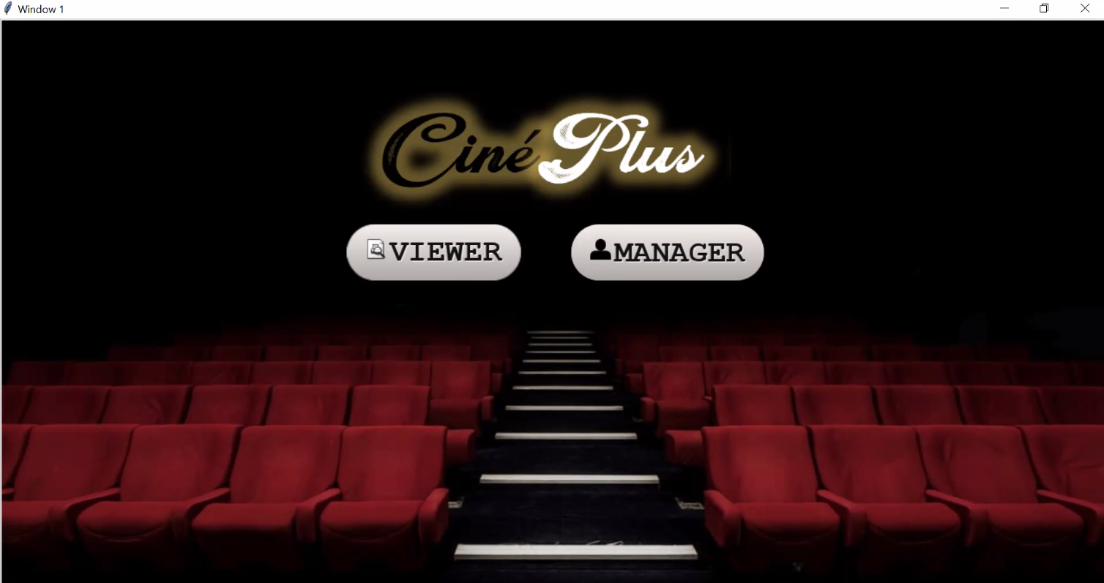As the program starts the following screen is displayed. It asks the user to either sign in as a viewer or as the manager.

Viewer

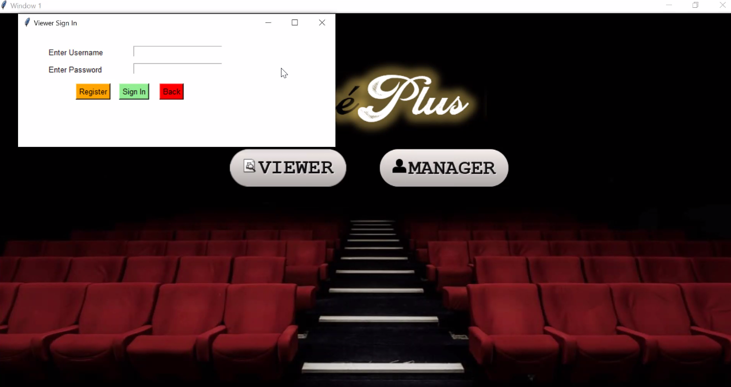If the user clicks on “Viewer”, the program prompts the user to either register (if they are a new user) or sign in (if their account already exists) by entering their username and password.

If the user does not enter any information or enters incorrect information of tries to register with an already existing (username,password) pair and clicks sign in, the following errors are generated respectively.

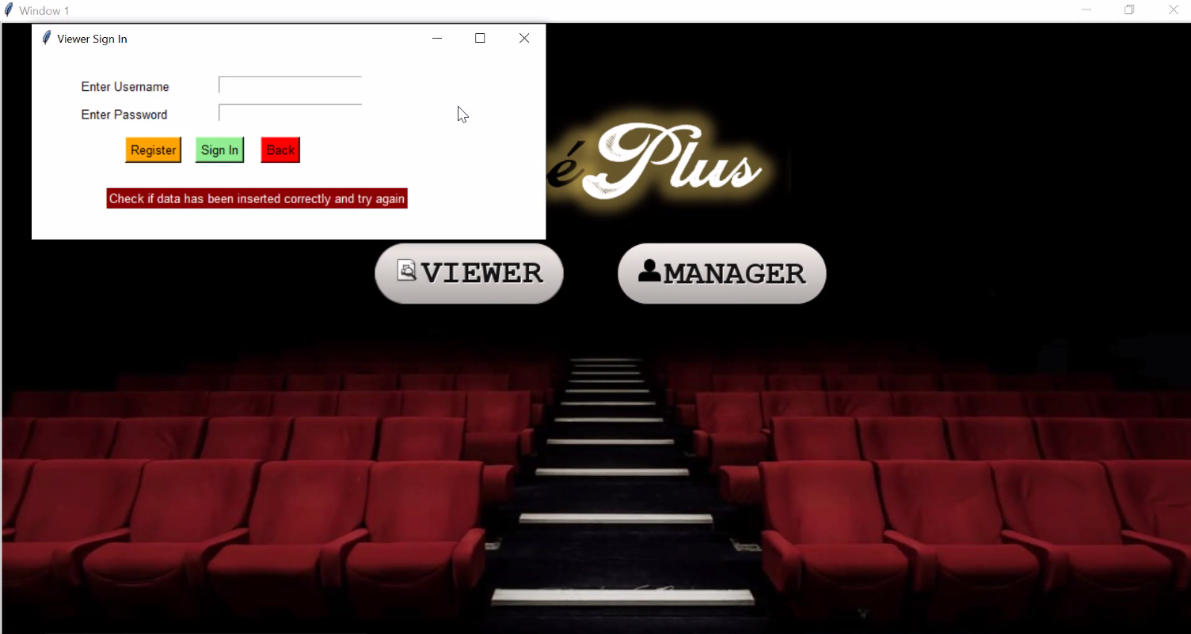

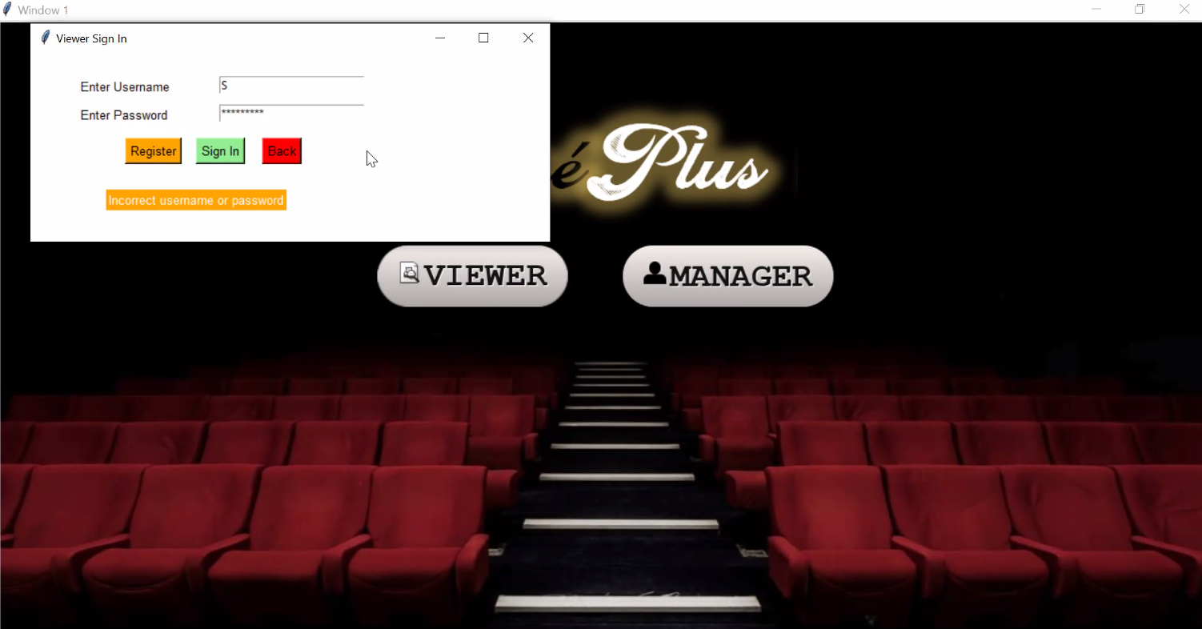

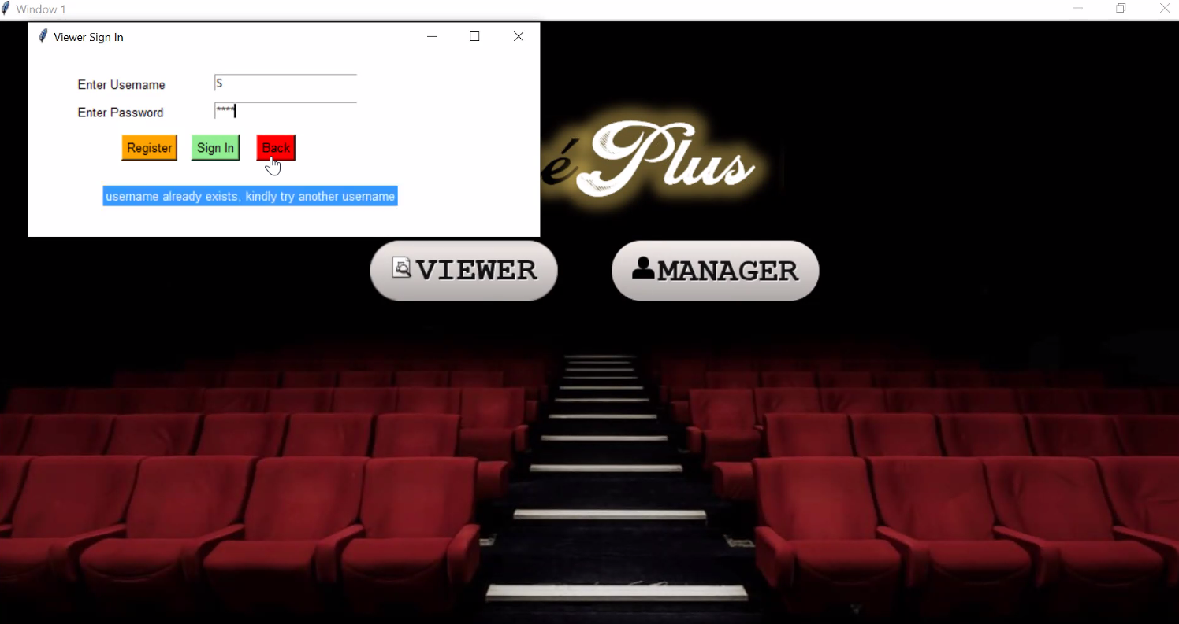

After signing in, the following screen is displayed where the user can choose their desired movie genre and click go.

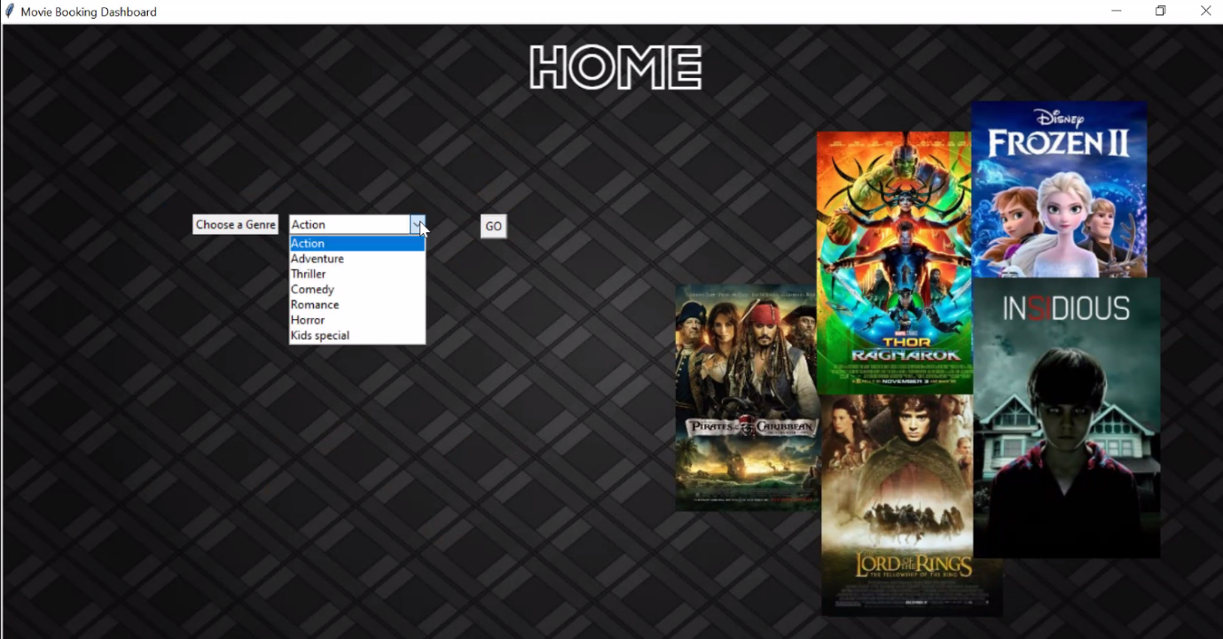

For demonstration we have taken “Action” as the chosen genre. The following screen is thus displayed.

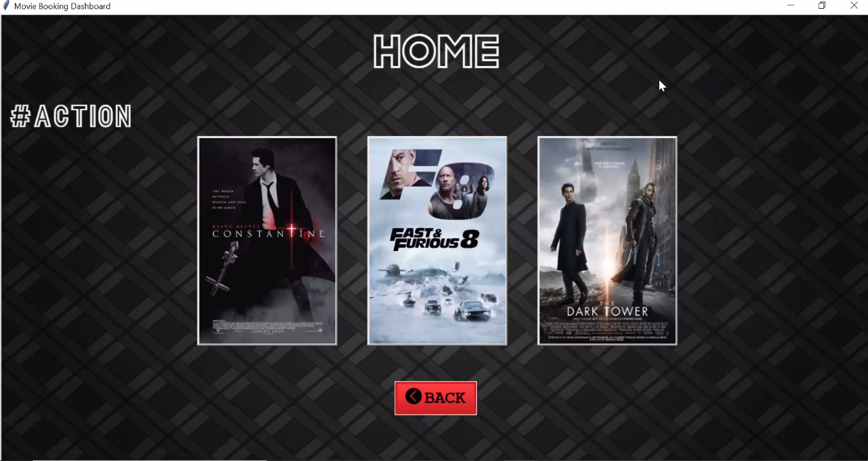

The user now can click on any of the displayed posters to obtain the movie details.

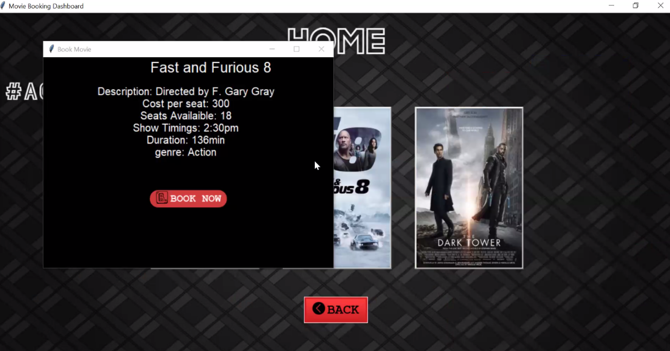

If the user chooses to book the movie by clicking on “BOOK NOW”, the following details are asked from the user.

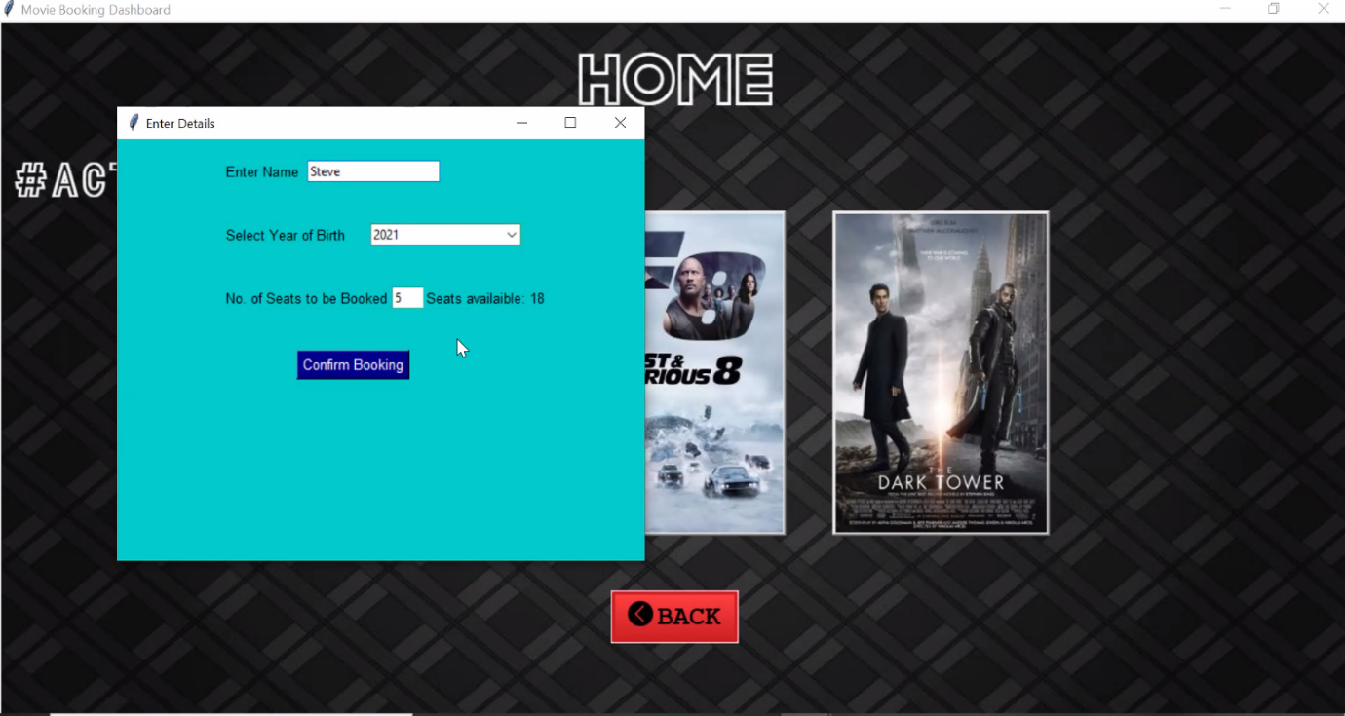

As the user confirms the booking the following message is displayed.

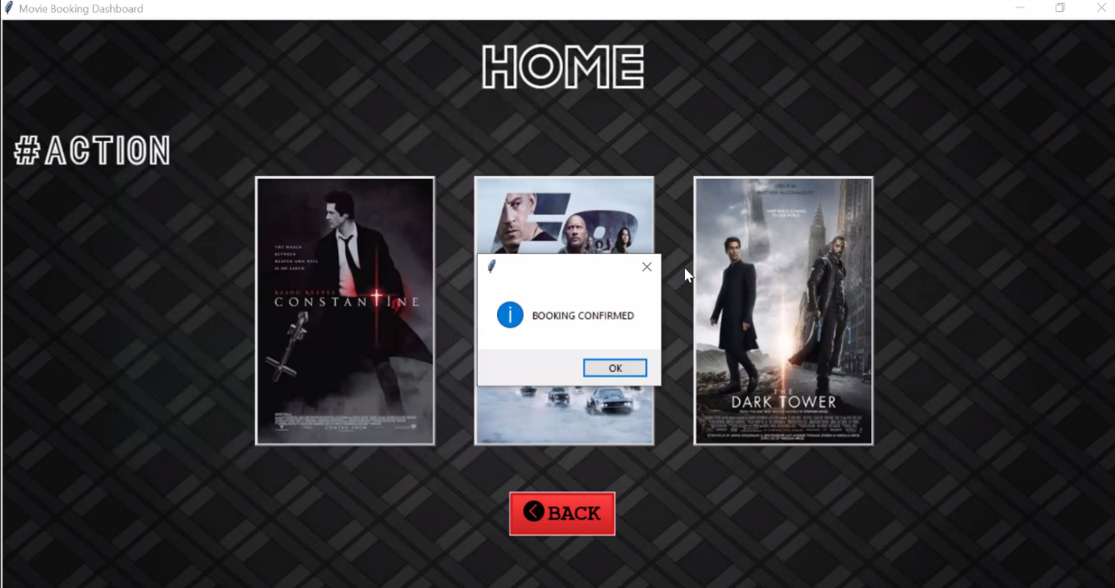

NOTE: The no. of seats available has been updated.

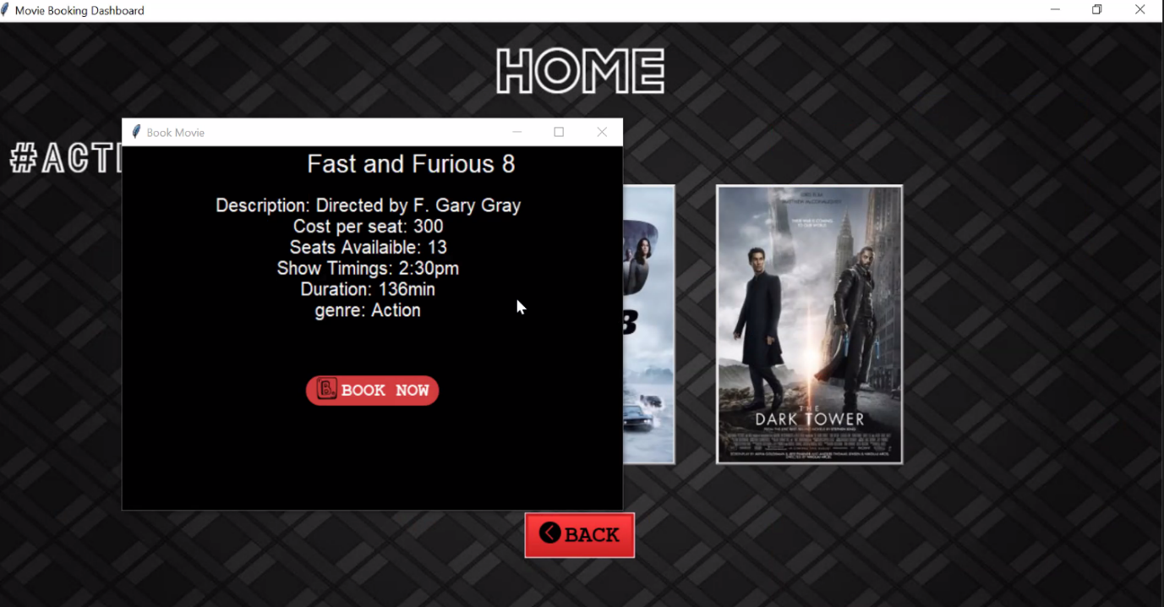

Now, the user can go back and book more movies as per their wish.

Manager

If the user clicks on “Manager”, the program prompts the user to enter their username and password.

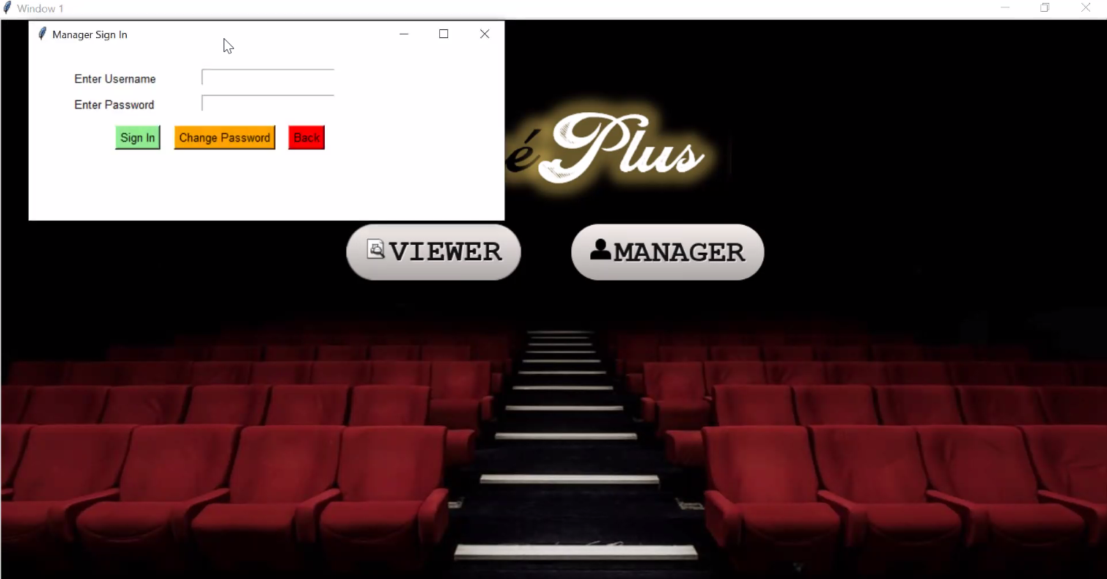

Here, the user is also given an option to change their password.

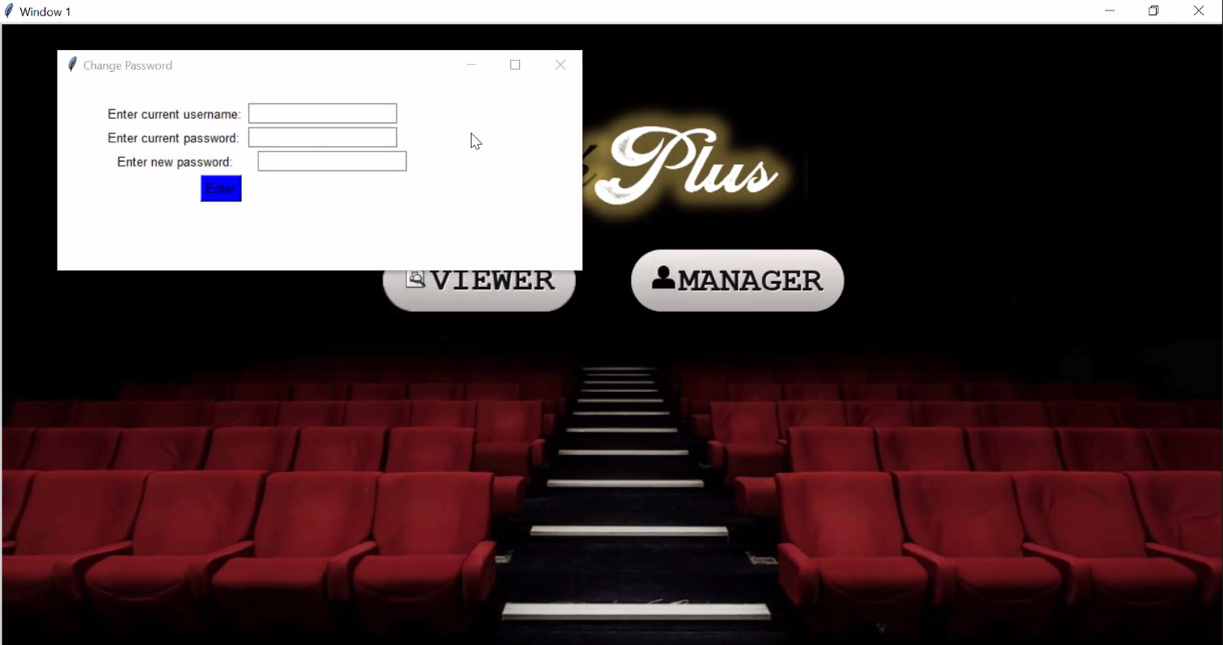

While signing in, if the user enters wrong credentials then, the following error is generated.

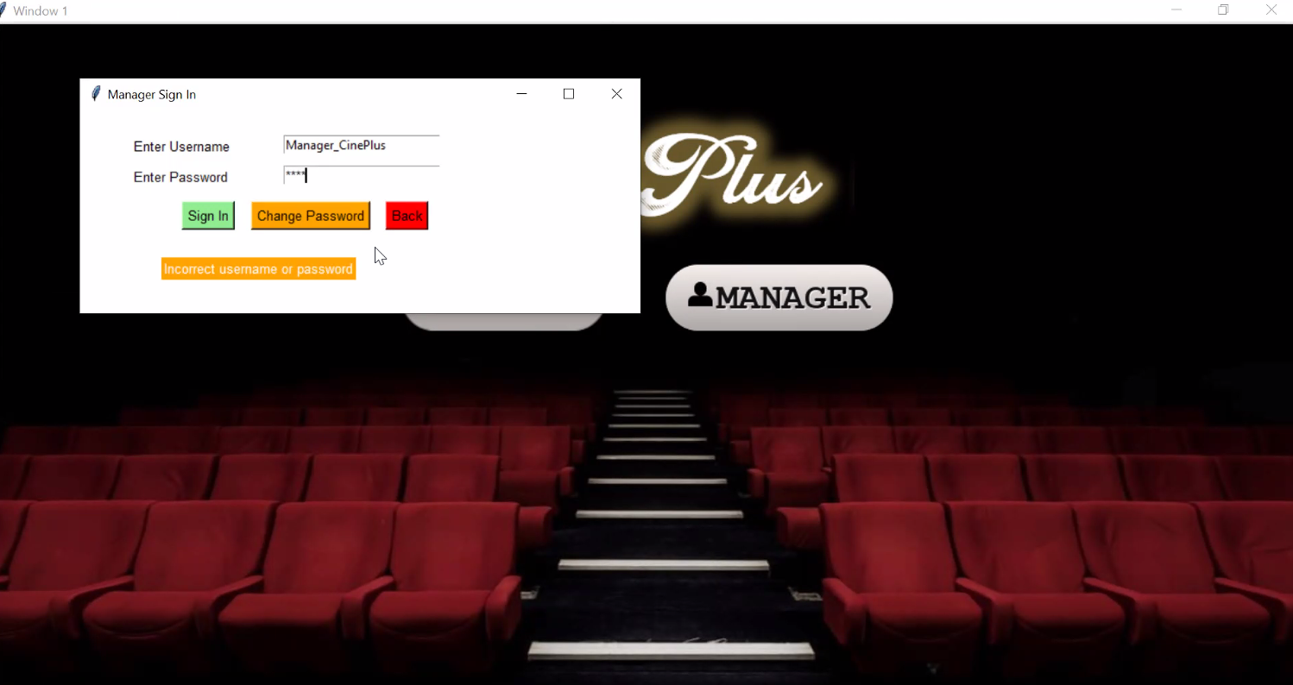

As the user signs in, the following screen is displayed.

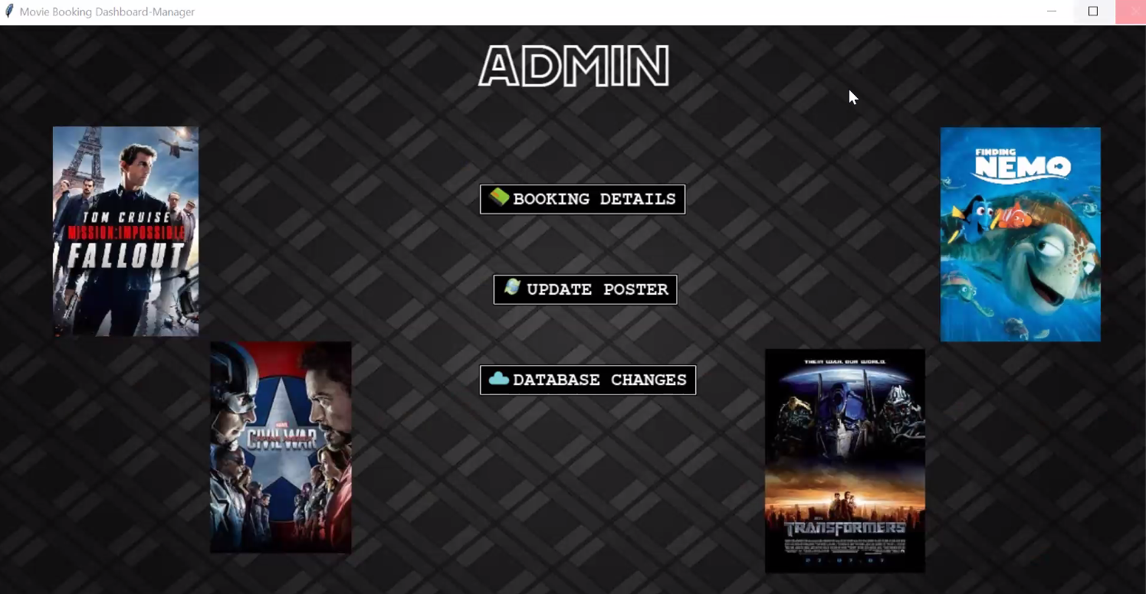

If the user click on “BOOKING DETAILS” , a popup is displayed which shows all of the bookings done through the viewer portal.

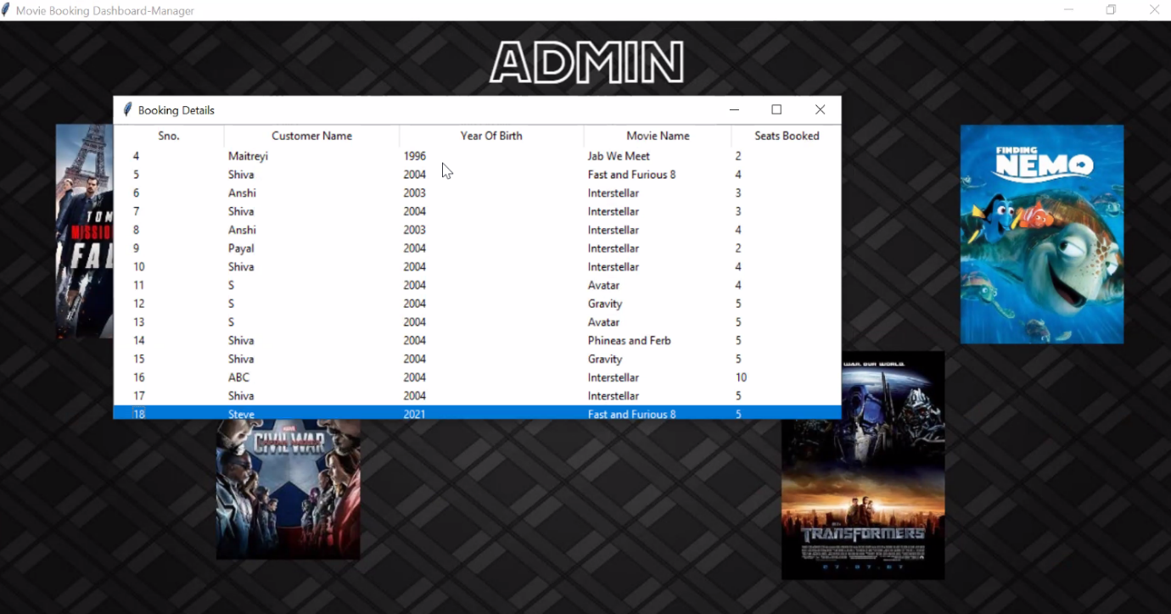

If the user clicks on “UPDATE POSTER”, a screen similar to the one in the viewer portal is displayed. The manager can choose any genre in which they want to update the poster. For demonstration we have chosen the genre “Kids Special”.

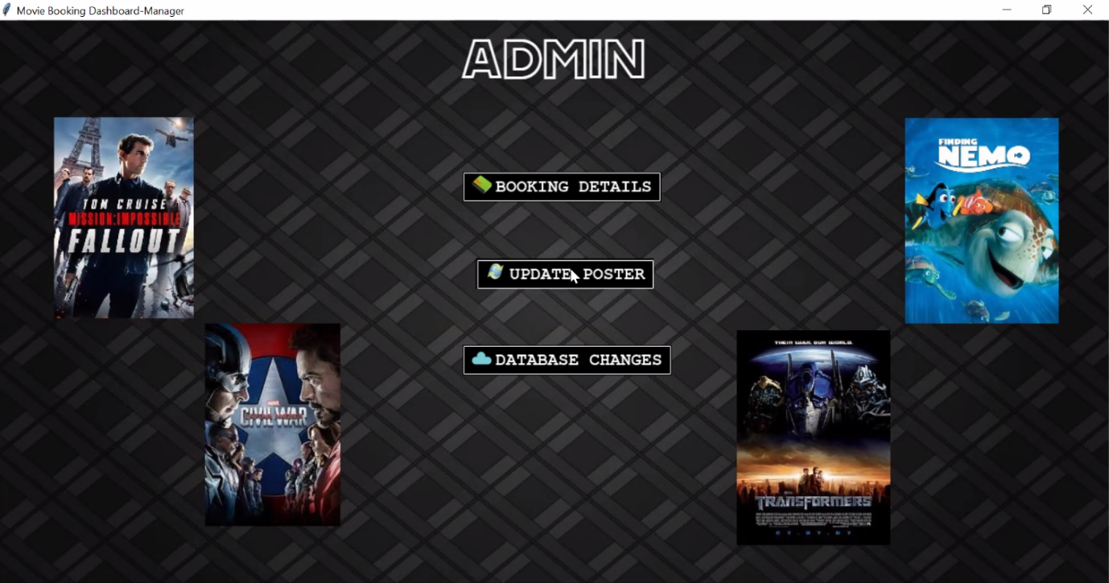

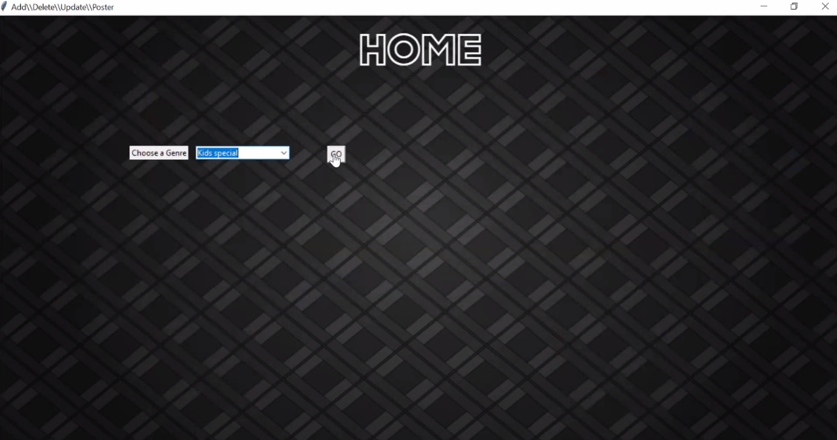

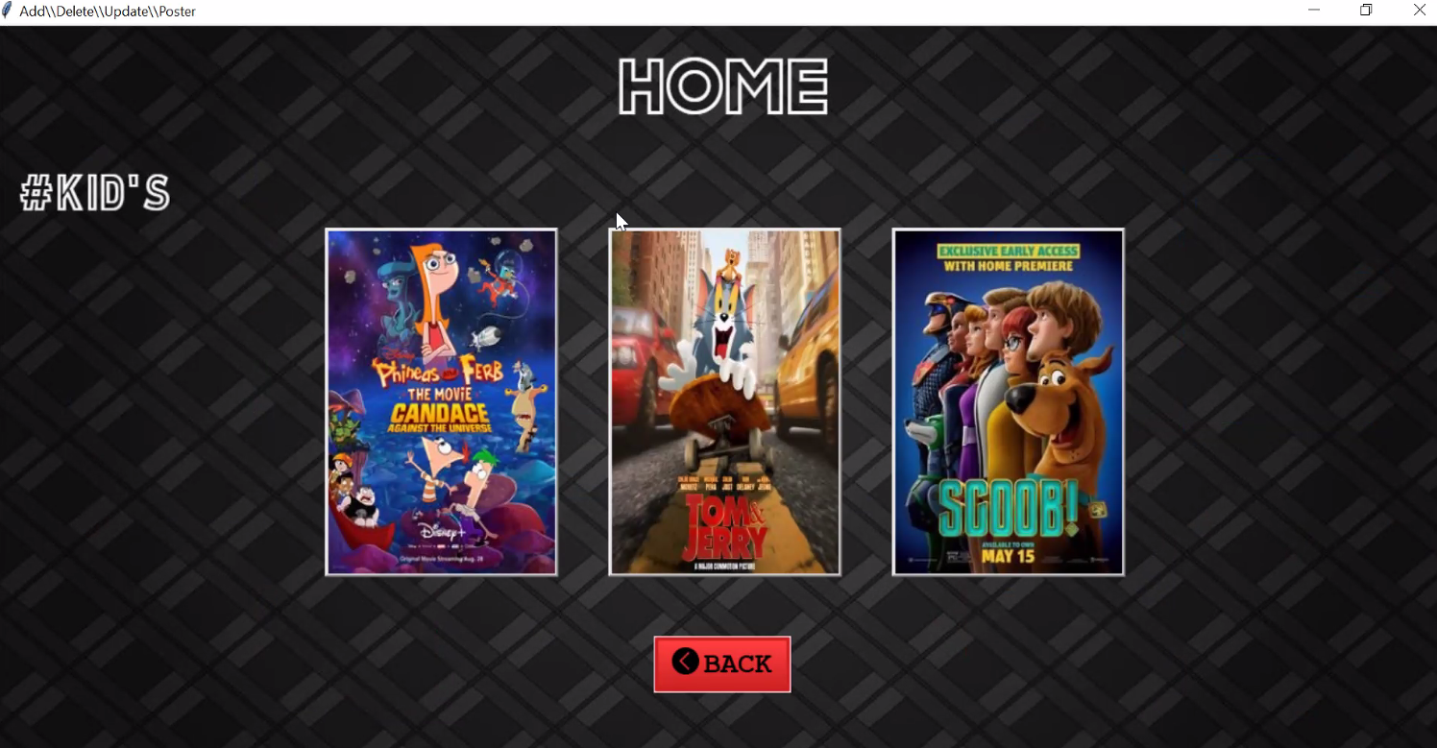

The manager can click on the poster they want to change. As they click on the desired poster, they are prompted to enter the new movie name whose poster has to be placed in the selected poster’s place.

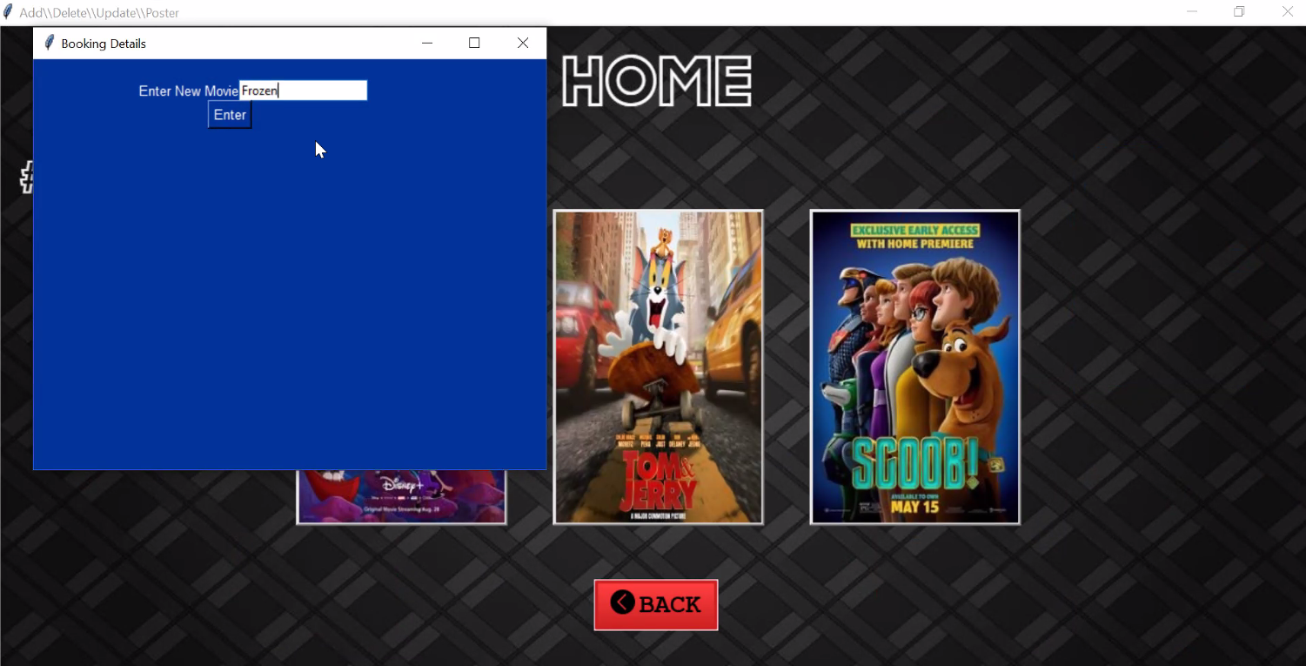

On clicking “Enter”, the desired poster is updated.

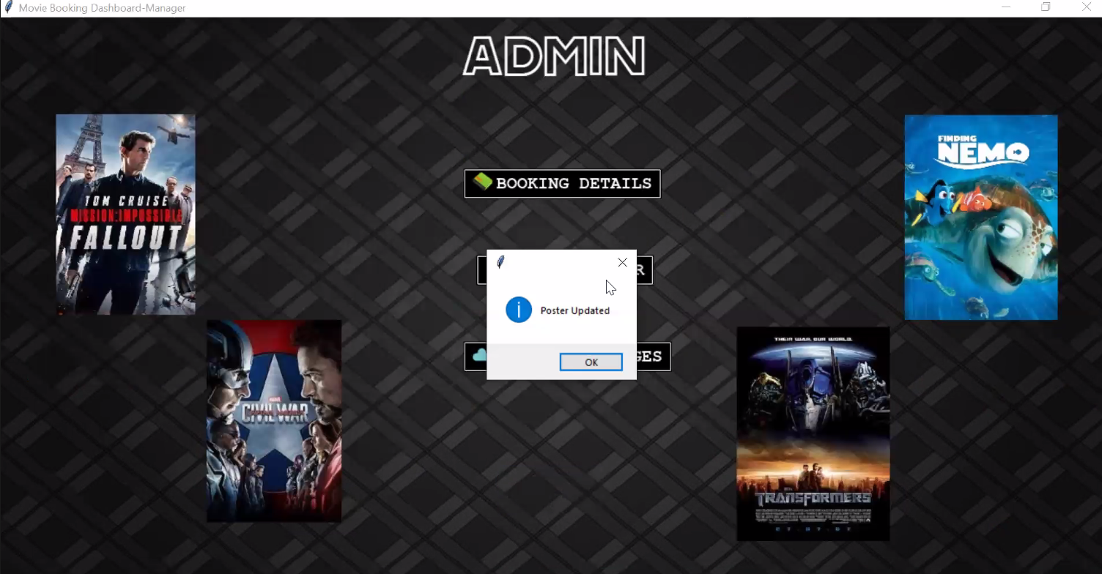

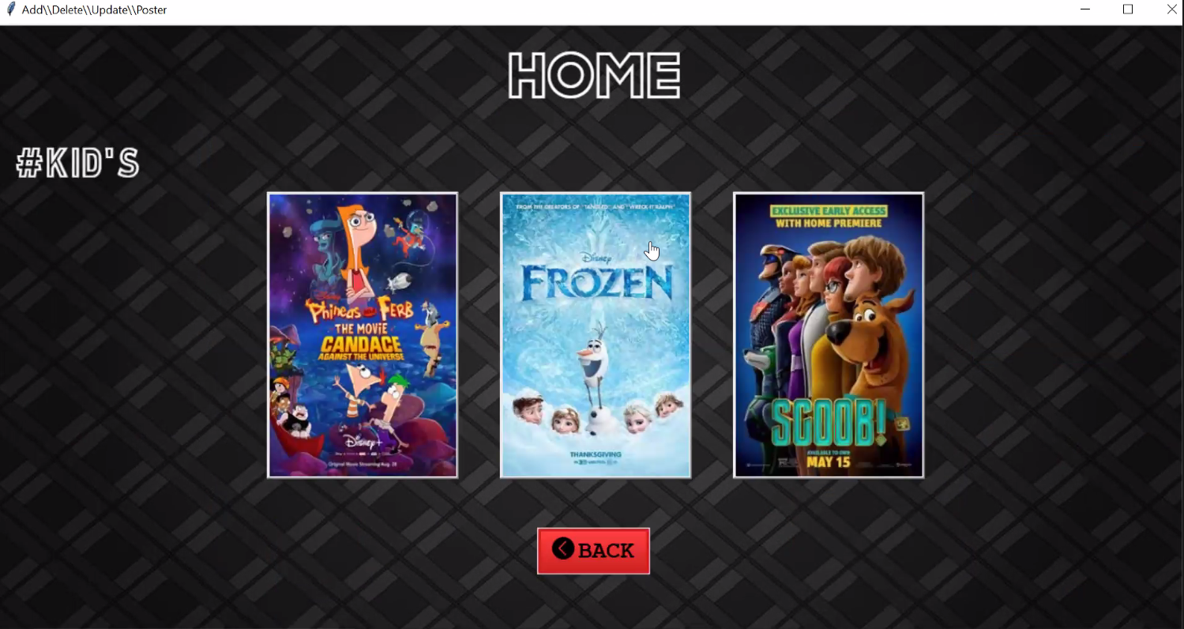

Back on the Admin Page. If the user clicks on “DATABASE CHANGES”, the following screen is displayed.

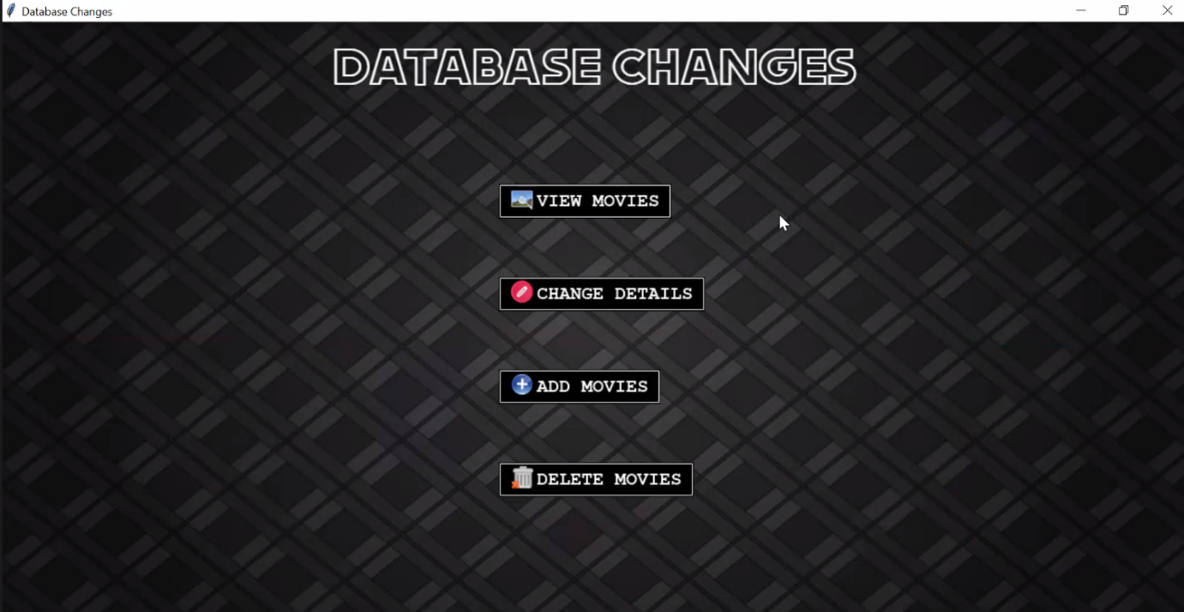

On clicking on “VIEW MOVIES”, the following screen with the complete details of all movies is displayed.

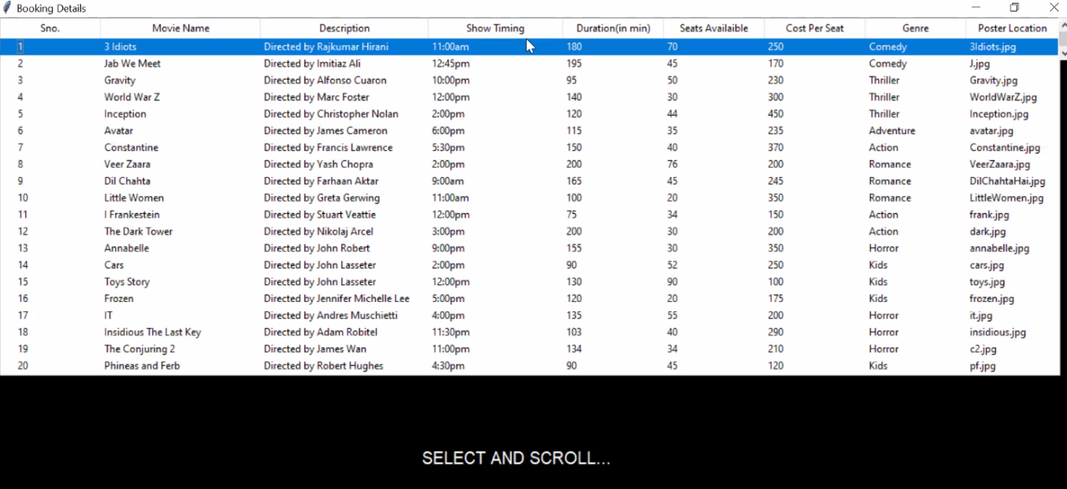

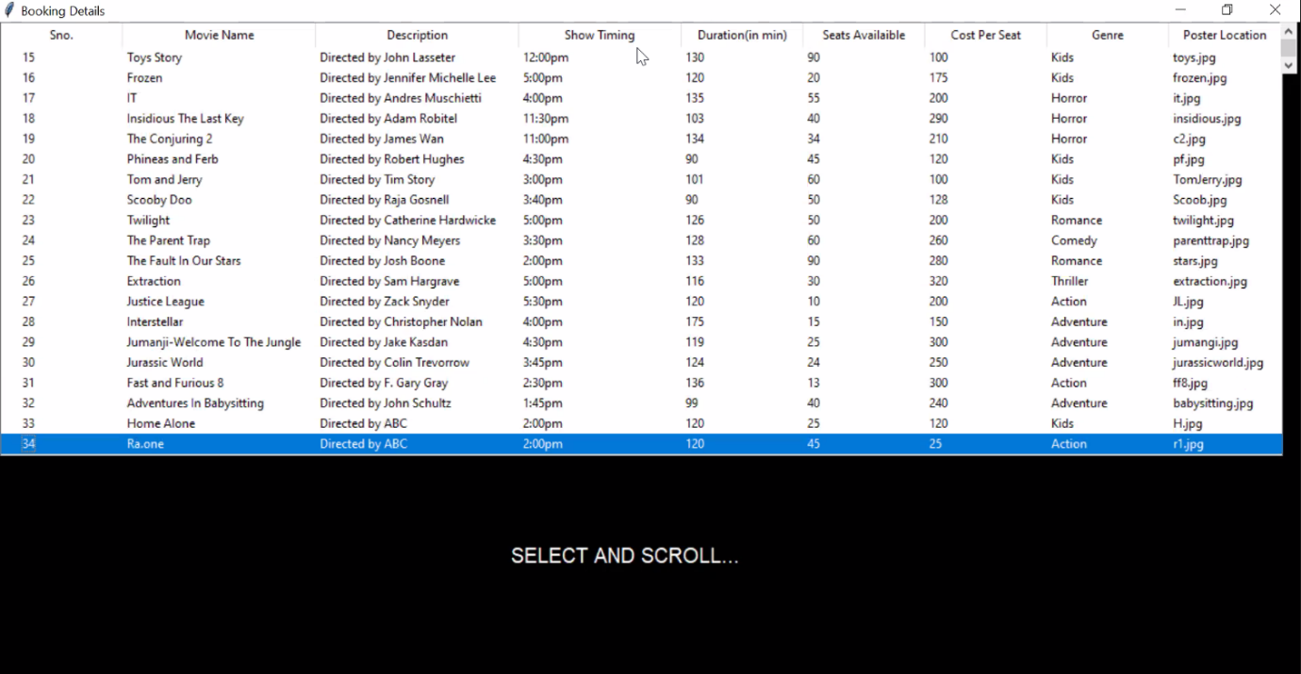

On clicking on change details, a popup is displayed which allows us to make a specific change in the movie details.

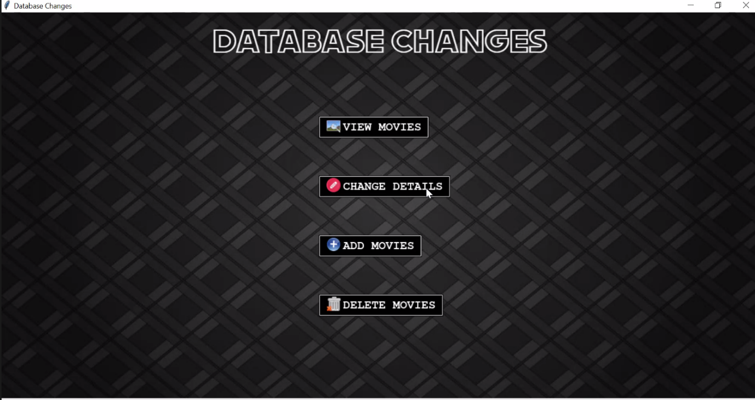

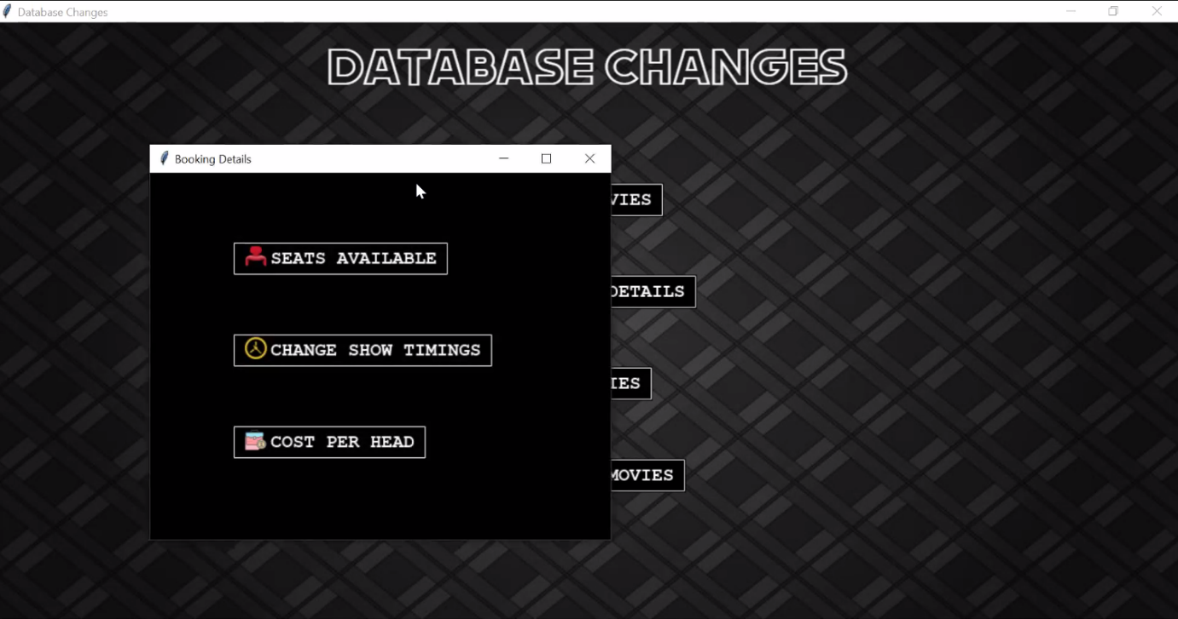

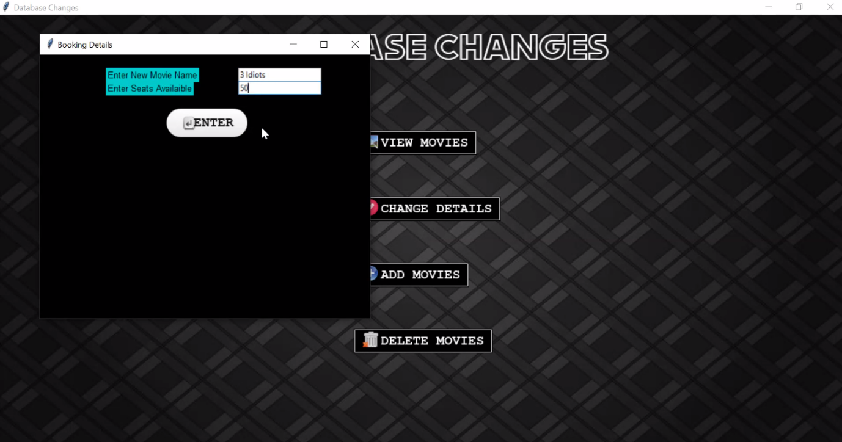We can further make any necessary changes in the movie details by selecting the respective button and entering the movie name whose detail has to be changed and the new details.

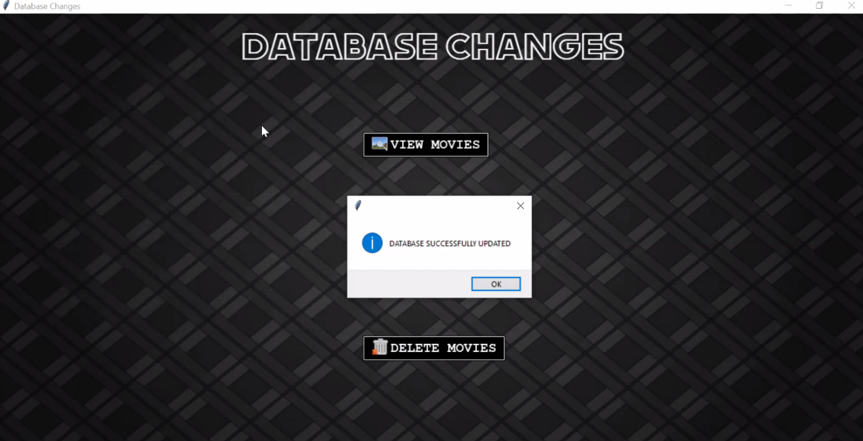

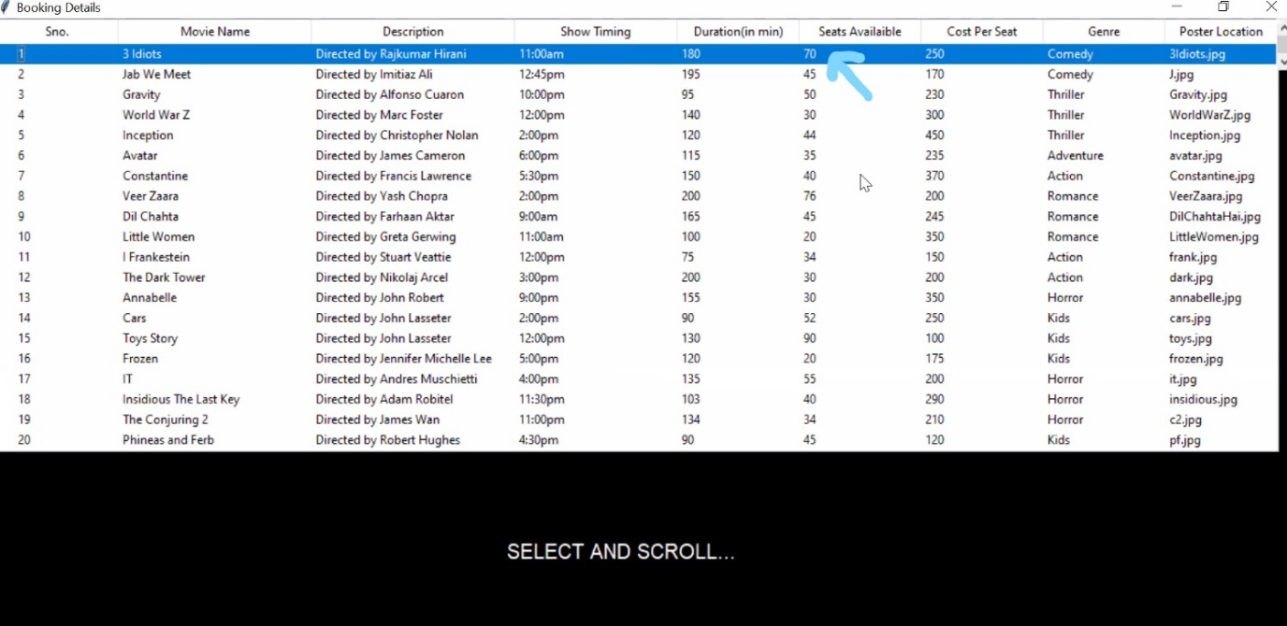(Before change)

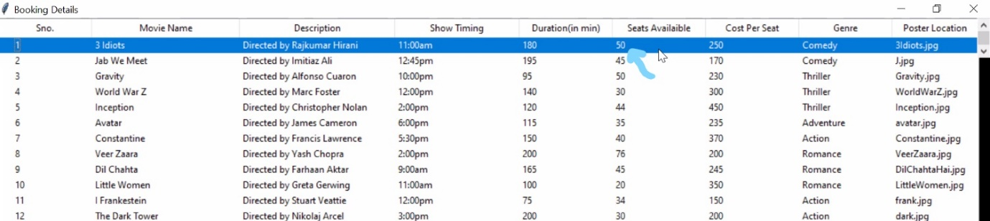(After change)

If the user clicks on “Delete movie”, they are prompted to enter the name of the movie to be deleted and the required message is displayed.

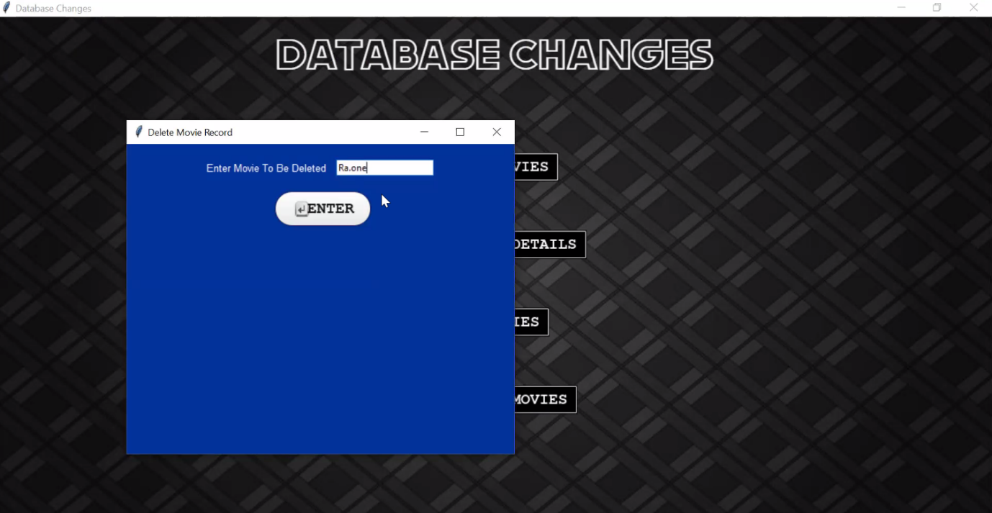

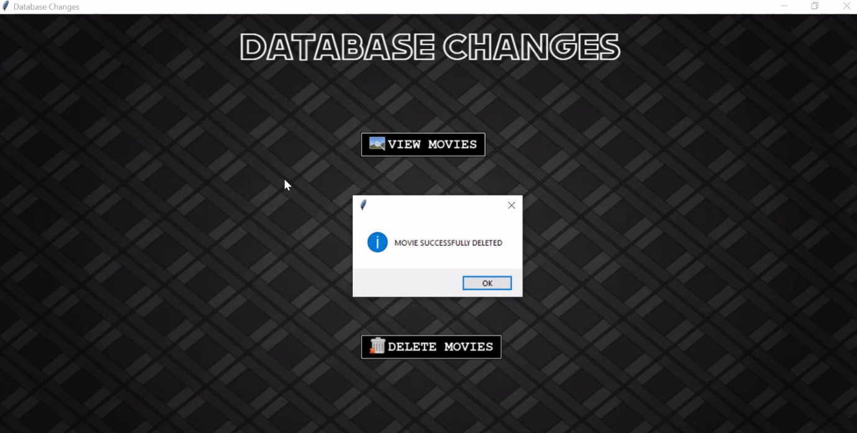

We can observe this change through the “View Movies” Button.

Similarly, we can add a movie to the database by entering all the required details.

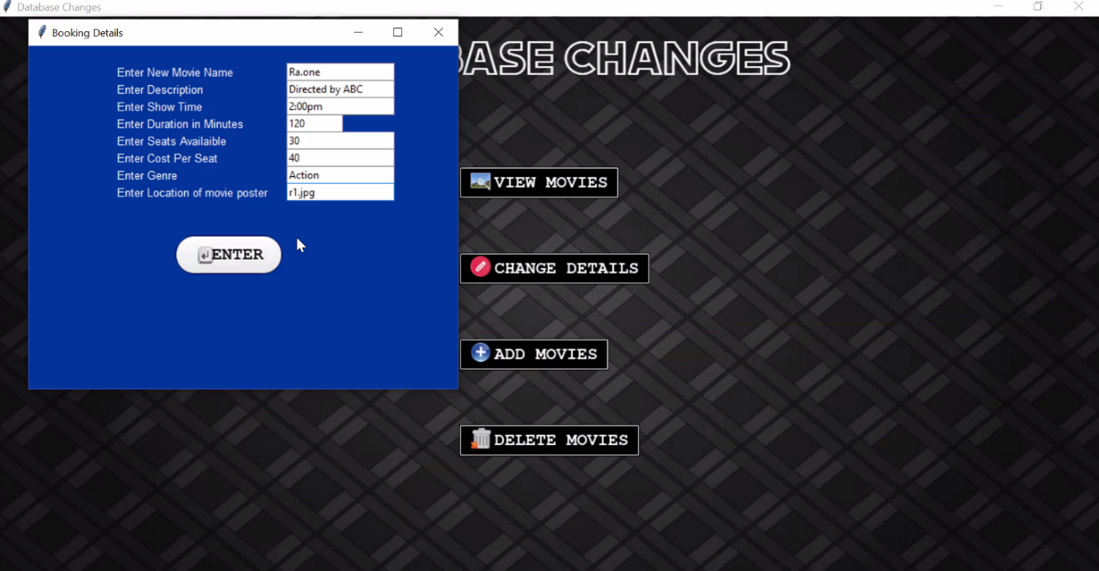

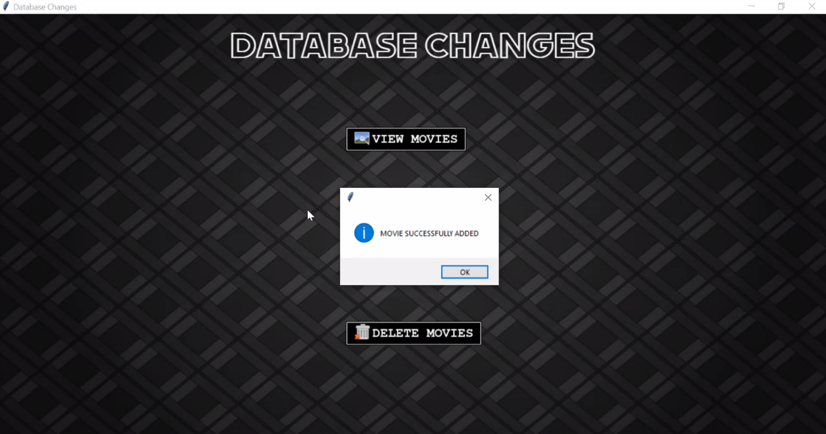

# CONCLUSION

The entire project with its thousands of lines of code and the tremendous amount of time and energy that has spent by the group on this project has successfully borne fruit and the program works quite well.

This project shows the working of MySQL and Python and also provides a program that can be utilized to book movies both in the online and offline domain.

# FUTURE IMPROVEMENTS

Due to lack of time we were unable to make further developments. However, the following improvements can be introduced in the future:

1. An OTP system
2. An invoice generator to provide a detailed record for the user.
3. Upgrade the graphical interface
4. Online snack booking
5. A subprogram for offers and discounts

# BIBLIOGRAPHY

1. <https://www.geeksforgeeks.org/>
2. <https://stackoverflow.com/>
3. <https://www.youtube.com/>